**III. ACADEMICAL VILLAGE**

**TABLE OF CONTENTS**

|  |  |  |
| --- | --- | --- |
| **ARCHITECTURE:** | |  |
| **1.** | **Basic Architectural Information** | **…125** |
| **2.** | **The Classical Vision in America** | **…129** |
| **3.** | **Thomas Jefferson and Architecture** | **…132** |
| **4.** | **Early Designs and Construction** | **…137** |

|  |  |  |
| --- | --- | --- |
| **STORIES:** | |  |
| **5.** | **“A Revolutionary Reunion”** | **…142** |
| **6. The Rotunda Fire of 1895** | | **…145** |
| **7.** | **After the Fire** | **…149** |
| **8. The 1976 Rotunda Restoration** | | **…153** |
| **9.** | **2012-2016 Rotunda Renovations** | **…157** |

|  |  |
| --- | --- |
| **THE ROTUNDA, ROOM BY ROOM** | **…159** |

|  |  |  |
| --- | --- | --- |
| **THE LAWN:** | |  |
| **10.** | **Exterior of the Rotunda** | **…178** |
| **11.** | **The Pavilions of the Lawn** | **…181** |
| **12.** | **Other Aspects of the Village** | **…186** |
| **13.** | **Pavilion Residences** | **…189** |
| **14.** | **Lawn Room Residences** | **…190** |



**!****PART 1: ARCHITECTURE**



**Basic Architectural Information**

**What is a classical order?**

A classical order is one of the ancient styles of building design, in Greek and Roman tradition. Each “order” is distinguished by its proportions and characteristic profiles and details, but is most readily recognizable by the type of column it employs. The different characteristics of each order raise certain expectations for an audience attuned to the architectural language.

**What are the five different orders?**

From the sixteenth century onwards, theorists recognized five orders. Three ancient orders of architecture originated in Greece. Ranging from simplest to most ornate, they are the **Doric**, **Ionic**, and **Corinthian**.

To these the Romans added: the **Tuscan** (which they made simpler than the Doric) and the **Composite** (which was more ornamental that the Corinthian). Both are essentially modifications of Greek orders. That is: each Greek order shows invention and individual character, each is distinct. The two Roman orders, however, are completely borrowed, and only differ from the Greek orders accidentally.

**What are the parts of an order?**

The **entablature** (the horizontal structure supported on the columns like a beam) consists of three horizontal layers: the molded **cornice** at top, the **frieze** in the middle, and the **architrave** at bottom. Each is visually separated from each other using moldings or bands.

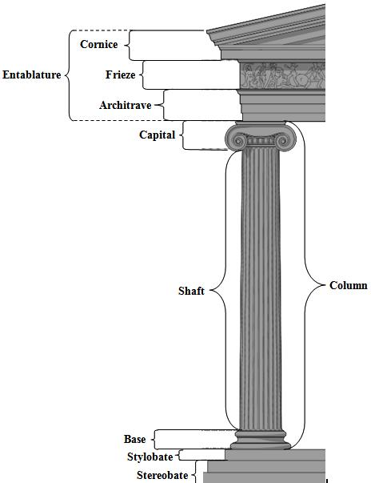In Roman and post-Renaissance work, an **arch** may spring from the column, carrying the entablature from column to column.

The **column** is divided into a capital, a shaft, and a base.

* The **capital** rests on the shaft. Though it has a load-bearing function (concentrating the weight of the entablature on the supportive column), it primarily serves an aesthetic purpose, distinguishing the different classical orders through its distinct characteristics.
* The **shaft** is placed vertically on top of the base. It is cylindrical, long, and narrow. It is sometimes articulated with *fluting* (vertical hollow groves).
* The **base**’s lowest part is the *plinth*, a square or circular block. The remainder of the base may be given one or many moldings with profiles, like the convex *toms* and the concave *scotia* separated by *fillets* (bands).

The column is placed on a flat pavement called the **stylobate**, which itself stands upon the **stereobate**.

**The Five Orders in detail from simplest to most ornate**

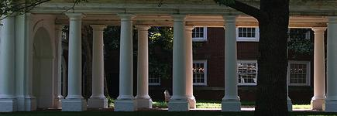

**The Tuscan order**

The Tuscan order is a simplified adaptation of the Doric order by the Romans. It has a very plain design, with an un-fluted shaft, and a simple base, capital, and frieze.

The Tuscan columns are largely indistinguishable from the Doric columns at the University, since the Doric columns at UVa are un-fluted and have bases. The distinction is with their vastly different entablatures and subtle differences in the capitals.

**Examples at UVa:** Colonnade on Lawn, Pavilion VII, and Rotunda main floor hallway. The Tuscanorder is considered the lowest order, and, therefore, the Tuscan order was used for the colonnade in front of the Lawn rooms, as students are the lowest rungs on the ladder.

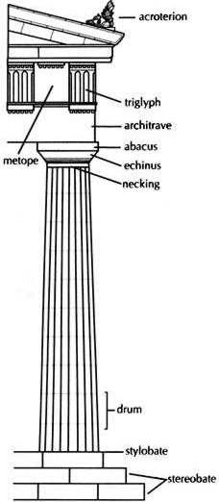**The Doric order**

The Doric order is the simplest Greek order, characterized by short, heavy columns with plain, round capitals. The shaft of the Doric order is often channeled with 20 flutes.

The architrave is either smooth or divided by horizontal lines. The frieze is divided into *triglyphs* and *metopes.* A triglyph is a unit consisting of three vertical bands separated by grooves. Metopes are plain or carved reliefs, e.g. the face of Apollo.

The Greek form of the Doric order comes without an individual base. Instead, the shaft is placed directly on the stylobate. The Romans, however, added a base.

**Examples at UVa:** Pavilion I, Pavilion IV, Pavilion VII, Pavilion X and thePresident's Reception Room. Note that the columns at the University are not fluted, meaning that the primary distinction between Doric and Tuscan is in the treatment of the entablature and subtleties in the capitals themselves. Also, all the Doric columns at UVa—with the exception of those in front of Pavilion X— have bases, making them Roman.

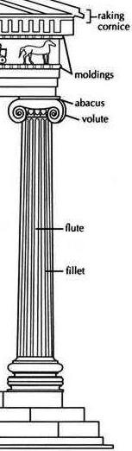**The Ionic order**

The Ionic order came from the Greek Aegean Islands. It is distinguished by slender, fluted pillars with a large base and two opposed *volutes* (also called scrolls) on the capital. The Ionic shaft comes with four more flutes than the Doric counterpart (totaling 24). The Ionic order is also marked by an *entasis,* a curved tapering in the column shaft. The architrave commonly consists of three stepped bands (called *fasciae*)*.* The frieze sometimes comes with a continuous ornament, such as carved figures.

**Examples at UVa:** Pavilion II, Pavilion V, Pavilion VI, Pavilion IX and North OvalRoom. Note again that the columns at the University are not fluted!

**The Corinthian order**

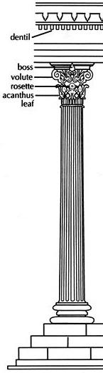The Corinthian order is the most ornate of the Greek orders, characterized by a slender fluted column having an ornate capital decorated with acanthus leaves. It is commonly regarded as the most elegant of the five orders. The most distinct characteristic is the striking capital. The capital of the Corinthian order is carved with two rows of acanthus leaves and four scrolls. The shaft of the Corinthian order has 24 flutes.

**Examples at UVa:** Pavilion III, Pavilion VIII, Rotunda Exterior, and BOV Room.

**The Composite order**

The Composite order is a mixed order, combining the volutes of the Ionic with the leaves of the Corinthian order. Until the Renaissance it was not ranked as a separate order. Instead it was considered as a late Roman form of the Corinthian order.

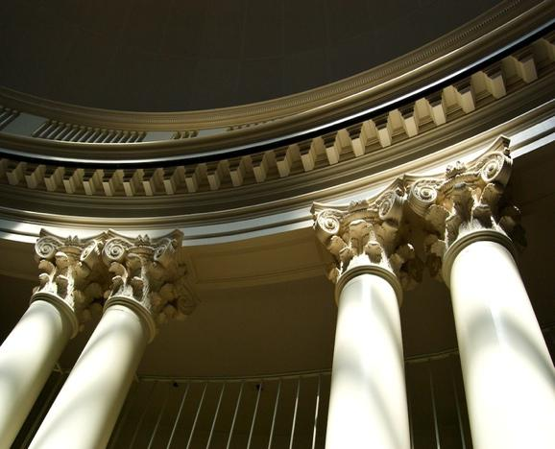**Examples at UVa:** The Rotunda Dome Roomis the *only* place at the original Academical Village that the Composite order can be found. This was by design. The Composite order is considered the greatest of all the orders, and the Dome Room was to be the library and the central fixture of the University of Virginia. The use of the Composite order in the library is symbolic of UVa’s founding as an institution that places the pursuit of knowledge and free inquiry at the heart of its mission!

**The Five Orders in the Academical Village**

All five orders are employed in the Academical Village. Additionally, there is a clear hierarchy of architecture in the use of the orders. The Tuscan order is used for the colonnades in front of the student rooms, while professors’ pavilions have the three Greek orders. Only the library (Dome Room) has the Composite order, indicating its primacy of place in the academic hierarchy.

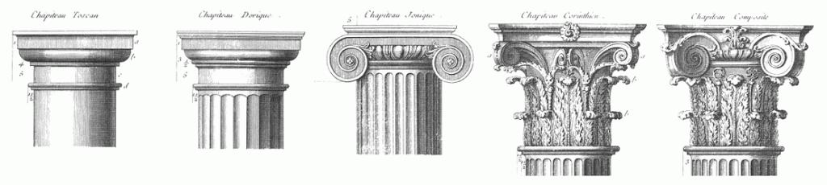It is also important to realize that, in the classical world, there were very strict conventions in terms of how the buildings using these orders were designed. Pavilions I and II are exact models of classic Doric and Ionic temples, providing a sort of exemplary display of the classical orders. However, as one progresses down the Lawn, the building facades become more and more experimental, exhibiting in physical symbolism how the fundamentals of classical learning (represented by Pavilions I & II) can be used in other ways to create new forms and ideas.

**The Classical Vision in America**

*Adapted from the* Encyclopedia of American Cultural and Intellectual History

**In what ways did the national imagination fixate on Greco-Roman iconography?**

One compelling characteristic of the American imagination from colonial times through the nineteenth century was the eagerness to endow what was new with the dignity and stability of the old. There were many examples: places named from Greek and Roman antiquity (e.g. Athens, Troy, Ithaca, Syracuse, or Cincinnatus); iconography in the United States seal, like an eagle which symbolizes Zeus, or the Latin phrases like *e pluribus unum* adapted from the Roman poet Virgil; and most importantly, a democratic form of governance.

The English mathematician Alfred North Whitehead intuitively recognized the debt of the framers to classical antiquity when he observed, “I know of only three times in the Western world when statesmen consciously took control of historic destinies: Periclean Athens, Rome under Augustus, and the founding of your American republic.” The political scientist Hannah Arendt put the matter more directly: “Without the classical example… none of the men of the revolutions on either side of the Atlantic would have possessed the courage for what turned out to be unprecedented action.”

When, after the failings of the Articles of Confederation, Washington reluctantly agreed to serve as a delegate from Virginia at the Constitutional Congress in Philadelphia, firmly fixed in his mind was the example of the ancient Roman citizen-solider Lucius Quinctius Cincinnatus, who likewise assumed military command at the request of the citizens to save the Roman state. Then, when his work was done, he happily returned to his farm.

Even ideas like the Separation of Powers are rooted back to Greek philosopher-mathematician Pythagoras who believed that antithetical forces exist on a cosmic level not to pull things apart, but so that the tension between them may keep the universe in balance. What’s more, although as an instrument of governance the Bill of Rights is an American invention (indeed only six of the 27 provisions were first stated in the Magna Carta of 1215), all but one of those provisions—freedom of the press—have roots in classical antiquity.

**Thomas Jefferson’s influence of Classical Architecture in America**

After the Revolution was won and the manner of governance determined, the United States was faced with creating a civic architecture that would reflect its new aspirations. During the colonial period, public buildings generally reflected those of the same Georgian architectural period in Europe. Now Americans wanted to offer a new face to the world, one that would nevertheless symbolize stability and continuity.

For D.C. architecture, we know when, where and to whom to look for the formative inspiration and ethos. In 1785, Thomas Jefferson paid a visit to the *Maison-Carrée* in Nîmes, France (a Roman temple built in 16 B.C.). By his own account he sat there gazing at it for hours, “like a lover at his mistress.” For Jefferson this one building represented an entire culture. “The city of Rome is actually existing in all the splendor of its empire,” he wrote. Jefferson modeled his design for the state capitol of Virginia in Richmond (erected in 1788) on this temple. Later he chose classical models, especially the domed Roman Pantheon, for his home at Monticello, near Charlottesville, and for the central rotunda at the University of Virginia. While in 1790 Washington chose the site for the new national capital at the head of the Potomac River, it was Jefferson who worked with the architect Pierre L'Enfant to envision the layout and aspect of the city. As Garry Wills put it, “Jefferson took the first steps that stamped America's federal city as a Roman town… New ideas were more daring the older they could claim to be.” Washington, D.C., was not going to be another London, but a new instantiation on American shores of a now truly democratized Roman republic. Thus Jefferson rebuked the architect Benjamin Latrobe for not offering a design for the Capitol along Roman lines, which Jefferson's own anonymous submission embraced. The most significant precedent of all was the soaring dome of the ancient Roman Pantheon (which, to Jefferson’s delight, provided the inspiration for the original dome of the United States Capitol).

Besides their grandeur, the new public buildings were to represent purity of form, symmetry, and proportion. American tastes changed in about 1840, and no new public buildings were built in Washington in the neoclassical style until the twentieth century, when L'Enfant's plan was resurrected. The Lincoln Memorial, completed in 1922 and easily compared with the Athenian Parthenon, and the Jefferson Memorial, completed in 1943 and referring both to the Roman Pantheon and Jefferson's own Monticello, completed the grand plan.

**Key Takeaways: The Uses of the Past**

America embraced a multitude of appropriations of the Greek and Roman past, each for different ends and purposes. Ultimately, because of the founders’ extensive classical education, they had a very long sense of history. From this perspective they learned how to avoid mistakes of the past, even as they were crafting a workable plan for the future.

In governance, civic architecture, literature, and politics, Americans, like the ancient Athenians, have never been afraid to innovate. Like the Romans of the republic, however, Americans also yearned to preserve what is good. This combination of innovation and preservation, encoded in the Constitution and implanted in habits of heart and mind, gives Americans the continuing capacity to adapt the guidance of the past to an uncharted future.

**Commentary: How does this relate to our tours at UVa?**

It gives you a context for the inspiration and importance of Jefferson’s architecture.

Like many founding fathers, early in Jefferson’s life at his southern plantation home, a Scottish tutor educated him in classical enlightenment because he needed to pass college entrance exams. But Jefferson *loved* it, and even referred to these authors as “friends”.

The main concept Jefferson took away from these lessons was the concept of *fama*: your lasting contribution, your legacy, the memory you leave behind. This is why he kept every letter he wrote, why he kept building things, why he was always drawn back to the public life to make a difference, and why *he* wrote his own epitaph.

Classicism guided all the founding fathers in shaping their republican institutions, but they were ultimately not very optimistic about democracy. Seeing as the only democratic example the world had had was Athens (which was full of demagogues), after the Revolution the question became: how do you stop this cycle of virtue, decadence, and decay? How could their *fama* protect the democracy?

One of the big reasons Jefferson founded UVa was to produce good, republican citizens, so that the Revolution his contemporaries fought for wouldn’t die. UVa’s Greek and Roman architecture and buildings would remind his students of this; their environment and surroundings put the founding fathers’ virtues all around them.

Furthermore, progress was the new, big ideal of the Enlightenment. UVa reflects Jefferson’s appreciation for this. UVa would use logic and reason to educate its students and to improve society’s morals and standards. The reason UVa became the nation’s first secular university was so students could have the freedom to explore their own studies and access truth without the church’s influence.

So really this “Classical Vision” permeates throughout UVa and is ingrained in our history… all because Jefferson was forced to read about it on a farm as an eight-year-old.

**Thomas Jefferson and Architecture**

*From the Monticello Education Department and from Richard Guy Wilson’s* Thomas Jefferson and the Creation of America’s Architectural Image

Jefferson’s was one of America’s first architects. His involvement in architecture was a serious endeavor, and Jefferson once said that “architecture is my delight, and putting up and pulling down, one of my favorite amusements.” At his death, he left over five hundred architectural drawings and related documents.

**How were architects trained in early America? Where’d Jefferson study architecture?**

There were few trained architects in America before the Revolution, as the colonies had no “schools of architecture” or classes to study the subject. Most colonial home designs originated from pattern books in England, and most builders and craftsmen were trained in Europe. Some architects were originally builders who trained under an apprenticeship before coming to America, like Jefferson’s friend Benjamin Henry Latrobe. Jefferson, though, was a self-taught architect (which makes his contributions even more remarkable), and was never reimbursed for his designs. Latrobe described Jefferson as “an excellent architect out of books”, as they were his main source of architectural knowledge.

**What books and time period specifically inspired Jefferson?**

His first exposure to books on architecture undoubtedly came in the library at the College of William and Mary, and at the extensive private collection of William Byrd of Westover. It was probably during this time that Jefferson was first introduced to the 16th century Italian Renaissance architect Andrea Palladio and his *Four Books of Architecture.* These books strongly focused on the architecture of Greece and Rome, and they’re considered Jefferson’s architectural Bible. Palladio’s influence on Jefferson’s early work is undeniable, and was his main source for ancient buildings. (Pavilion II displays the Ionic of the Temple of Fortuna Virilis in Rome, as published in Palladio.)

**Why did Jefferson prefer the classical designs of Greece and Rome?**

Jefferson looked at the precedent of prior buildings as models for the present day, and he viewed that designs for important buildings should be based upon the timeless monuments of the past. The reason Jefferson preferred the more classical designs structures was partly for the virtues they reflected. When choosing the Pantheon as the inspiration for the Rotunda and his designs for the U.S. Capitol, Jefferson saw the political symbolism, saying the Capitol would be “the first temple dedicated to the sovereignty of the people, embellishing with Anthenian taste the course of a nation looking far beyond the range of Anthenian destinies.”

But arguably more than their political resonance, his choice of buildings lay with their geometric perfections, order, and symmetry. Jefferson’s love of mathematics and geometry, combined with his aptitude for precision, measurement, and rules of proportion, went hand in hand with the principles of classical architecture. Jefferson believed that certain ancient buildings exhibited a perfection that should be followed. He said: “What is beautiful is harmonious and proportionable; what is harmonious and proportionable is true, and what is at once both beautiful and true is of consequence agreeable and good.” The Roman Pantheon’s perfect spherical form became an icon for him, adopting it for his unused 1790 scheme for the US Capitol, and also UVa’s Rotunda.

Lastly, the different orders of Greece and Rome gave Jefferson the opportunity to establish a hierarchy and varied importance of different buildings through his architecture.

**What else influenced Jefferson’s views on architecture?**

Jefferson’s travels and observation across the U.S. and abroad also inspired him (though he never visited Greece or Rome). As minister to France, Jefferson spent five years in the country under their architectural influence. He was able to meet and talk with the leading figures of the neo-classical movement. Jefferson was especially interested in the social theories being used in the design of prisons, universities, libraries, and hospitals. He was strongly drawn to the idea that these buildings were designed to improve the common good of the people, which in turn would lead to the betterment of society. He also studied works about modern buildings by Errand and de Chambray (whose book featured the Doric of Diocletian’s Baths in Rome, the inspiration for Pavilion I).

**What was Jefferson’s role as architect?**

Like most architects of his time, he not only designed buildings but also oversaw their construction. As an architect, Jefferson had to know the number of bricks needed, how much timber to use, how and where to order the glass and hardware, and how to lay out the ground plan. Notes and drawings from the University illuminate his deep involvement with every aspect of construction. He was even skilled in tools: in 1822 a visitor from Vermont saw the 79-year-old Jefferson take a chisel from the hand of a stonecutter and demonstrate how to turn the volute of a capital.

He was also actively involved in every step of the University’s founding: he selected the site, surveyed the land himself (at age 74!), planned the first curriculum, hired the first professors, and was involved in countless other aspects of the University, which shows his true and honest commitment to the University (and his tendency to micromanage…), and highlights that Jefferson truly believed he was rendering his last great service to his nation, both Virginia and the United States, with the founding of the University.

**What examples are there of Jefferson’s architecture today?**

Four major structures still stand today as monuments to Jefferson’s unique architectural ability and personality: his home, Monticello; the Virginia State Capitol in Richmond; the University of Virginia; and Poplar Forest, the octagonal home Jefferson built near Lynchburg, Virginia, as a retreat from the many visitors to Monticello.

**Monticello:** His main house became a life-long experiment in new ideas and forms. He took obvious pride in thepraise it engendered, called “infinitely superior to all other houses in America.”

**The Virginia State Capitol:** While in France, Jefferson was asked to suggest a design for the new Virginia StateCapitol. Jefferson submitted a design based on the Maison Carrée, a Roman temple in Nimes, France, and this concept became the first reproduction of a classic temple to be used for public use in the United States.

**University of Virginia:** Jefferson is also known for his design of the “academical village” at the University ofVirginia, one of the largest projects in the country at the time. He envisioned the University as a symbol of his democratic ideals for learning, and Jefferson intended for the buildings themselves to represent those ideals and serve as models of good taste for the students. His design plans again recalled the structures of the Roman republic. The domed Rotunda, modeled after the Pantheon in Rome, was to be the focal point of the institution and would be located on a higher elevation. Each pavilion on the Lawn features one of the five classical orders of Roman architecture.

**Other designs:** He designed his summer retreat at Poplar Forest. He also advised friends living in the Piedmont,such as James and Dolly Madison at Montpelier, and Governor James Barbour at nearby Barboursville. For Farmington, a plantation near Charlottesville, he designed a huge temple-fronted façade and entertainment rooms. He designed several county court houses in Virginia and various other public structures such as a jail. Jefferson additionally made designs for the Capitol and Executive Mansion in D.C. that were not executed. He was, however, involved in the competitions and selection of architects for both buildings in 1792.

**What does Jefferson’s architecture generally look like?**

There certainly is a Jeffersonian “look” or “style,” which might be characterized as red brick, white trim, classical details, and frequently, a full temple-fronted portico with large columns.

**Where did Jefferson generally locate his buildings?**

An interesting feature of his designs is his preference for a dominant placement of his buildings. Monticello (meaning “little mountain”) was placed on top of a prominent hill that gave it a sweeping view and asserted its importance. The site gave Monticello a presence on the horizon: he liked to have a large expanse of sky with the building rising up. The State Capitol was similarly placed on top of Shocko Hill, and for years it dominated the town of Richmond and the James River below. At the university, the Rotunda is placed at the highest point, and faces south so that it is silhouetted against the sky. (Extensive leveling operations – by slaves and freedmen, horses and mules – created a series of flat terraces on which the village could be built.)

**How did Jefferson work the landscape into his vision?**

Jefferson saw landscape design as integral to architecture, integrating his buildings into the landscape through gardens. Jefferson loved to garden, to “embellish grounds by fancy.” His landscapes imitated the many gardens and famous landscapes he toured in Europe. (He even altered the design of his trees at Monticello so that lower branches were trimmed but their tops remained united, to “yield a dense shade” similar to that of Europe.) At UVa, his gardens provide a more intimate space against the public lawn.

**So, what was Virginian about these buildings?**

Though his buildings weren’t wooden as was common at the time, they also weren’t the stone he probably preferred. He ended up using brick as his permanent material, which was very Virginian. (The technical ability to use stone did not exist in Virginia during his lifetime, so he’d often cover his brick with stucco and score it to resemble stone, as with the Virginia State House.)

The University’s pavilions display very smooth-faced brick with tight incised joints on the fronts, but the sides’ rougher brick and not-so-fine joints gave his work a certain tentativeness and lack of sustainability which showed that he never entirely broke with the “colonial manner.”

His floor plans did become more sophisticated over his career, but there always remained a Virginian element to them. Despite wrestling with symmetrical facades early on, his final plan for Monticello was ultimately irregular with different-sized rooms in the interior, typical of Virginian spatial planning.

Finally, consider Monticello’s hidden dependencies under the extended wings outside, or his dining room’s revolving service door and dumbwaiter for the wine cellar. Though architecturally ingenious, they served a very Virginian purpose: to remove the slave population from sight.

**How did Jefferson view his work for the public?**

Jefferson’s goal with his buildings was to provide Americans with an appropriate model for houses and public buildings, and to inspire future skilled architects and workers to design and build them. He criticized America’s complacency with shoddy, wooden, impermanent buildings that lacked taste and symmetry. (He said of wooden buildings: “Their duration is highly estimated at 50 years. Every half century then our country becomes a tabula rasa, whereon we have to set out anew…” So he instead chose brick and marble for his University.)

For Jefferson, his buildings could also become models of good taste for his countrymen to study and imitate. Jefferson predicted the Virginia Capitol would “improve the taste of my countrymen, to increase their reputation, to reconcile them to the rest of the world, and procure them its praise.” Architecture was a way to infuse art into a young country, especially for those unable to afford paintings or sculpture.

He hypothesized that were architecture considered a fine art at colleges then “perhaps a spark may fall on some young subjects of natural taste, kindle up their genius, and produce a reformation in this elegant and useful art.” Over thirty years later, Jefferson returned to this theme when he suggested that the University pavilions’ different faces might serve as “specimens of orders for the architectural lectures.” (The proposal for the teaching of architecture at the collegiate level came to naught, however, and not until the 1860s did M.I.T. create the first American school of architecture.)

**How did Jefferson promote classicism?**

Jefferson set about both promoting the few architects existing in the country, such as Benjamin Henry Latrobe, and providing training to young aspiring designers, such as Robert Mills who spent a number of months working with Jefferson’s books and drawings. (Mills went on to design the Annex to UVa’s Rotunda, as well as the Washington Monument.) Jefferson also trained workmen to design and draw orders. The enormous construction project for the University offered a training opportunity for the several hundred workmen employed there, many of whom carried Jeffersonian classicism throughout Virginia and the South.

**What were Jefferson’s views on stairs? What about natural light?**

Jefferson thought that staircases were a waste of space, so at both Monticello and UVa he pushed them to the sides of rooms, and often into corners or windows. But Jefferson was a huge proponent of natural light. Jefferson’s buildings are known for having large windows, skylights, and mirrors to reflect light throughout the room.

**What is “form and function?”**

In his buildings, Jefferson incorporates elements that are both functional/practical (e.g. providing shelter, housing a library) but also artistic/aesthetically appealing (e.g. symmetry and proportions). Examples:

* The Dome Room bookshelves are practical, but hidden to maintain the aesthetics of the room.
* Floating balconies make pavilions seem like one-story structures (maintaining the classical form), but the balconies are also functional and useful.
* Pavilions are classically beautiful, but they also had a distinct purpose in Jefferson’s mind: to serve as three-dimensions architectural textbooks and symbols of civic virtue.

**What is Jefferson’s legacy as an architect?**

Jefferson established an American architectural identity rooted in classicism. Jefferson’s style became the national norm for many years, and still typifies what many think of as a national architectural style. Classical architecture in America was non-existent before Jefferson; now look at Washington, D.C.

Jefferson took the classical models of France, England, Italy, Rome, and Greece (an architectural language often associated with monarchy, the church, and imperial power), and transformed it into emblems of the new American experiment with democracy. He loved to preach that well-designed buildings could animate the democratic mind, and felt classical architecture best represented the democratic ideals of America. As a founder of both a new republic and its first buildings, his personal ideals are indelibly stamped on both areas.

**Early Designs and Construction of the Academical Village**

**What did Jefferson’s early plans for the Academical Village entail?**

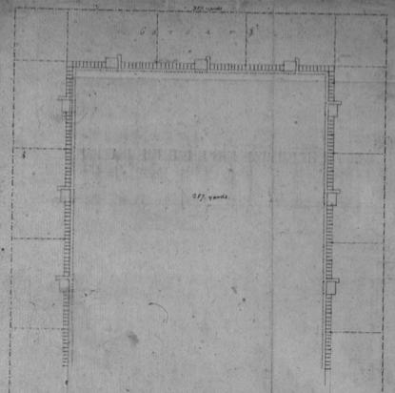As early as 1810, Jefferson had been describing the structure of a school that would eventually become the layout of the Academical Village. In 1814, he presented one of his first plans to the Board of the Albemarle Academy. His plan called for nine identical pavilions, three each around three sides of an open square. The three sides would all have covered walkways, so students would never be exposed to the elements while going to class (a design similar to the terraces and all-weather passages of Monticello where plantation activity could continue shielded from rain). The fourth-side was left open, presumably for expansion. At this time his plans showed no central building, and in one design *square* columns supported the covered walkways.

**Why did Jefferson seek outside help to design UVa?**

By 1817, Jefferson was anticipating success in turning Central College into the state’s first true public university, and thus began to expand the scope of his architectural plans. When he went to design the first pavilion for his proposed university, however, he had already sold all of his books. He was forced to turn to outside help, requesting James Madison’s personal copies of Palladio.

**Who helped Jefferson design the University?**

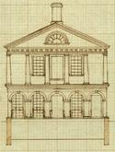Although Jefferson has surely earned the title Architect of the University, it is important to note that the contributions from fellow architects produced the Lawn we know today: namely **Dr. William Thornton** (original architect of the U.S. Capitol) and **Benjamin Henry Latrobe**.

**What did Thornton suggest the Lawn’s pavilions look like?**

Thornton’s designs suggested that each pavilion use arcades for its ground floor, with freestanding columns of different architectural orders on the second floor. Like Jefferson’s first design of Monticello, Thornton called for two architectural orders on top of the other, each one-story high. Pavilion VII (seen right), which was started the same year that Thornton gave his advice, was the result.

**Why did Jefferson not use Thornton’s design for the other pavilions?**

Thornton’s pavilions were all too similar, and thus did not correspond to Jefferson’s stipulation that they should “be good models of taste and good architecture, & of a variety of appearance, no two alike, so as to serve as specimens for the architectural lectures.” To wit, Thornton’s orders were not large and imposing enough for the pavilions to serve their didactic purpose as three-dimensional architectural textbooks for the students.

**Whose design did Jefferson follow for the other pavilions?**

Jefferson received his next and most crucial inspiration from Latrobe (who wrote on June 17, 1817 that he had “found so much pleasure in studying the plan of your College, that the drawings have grown in larger bulk than can be sent by the Mail”). His sketches were of pavilions with large colossal columns running the entire length of the building, rather than being separated into two, single-story orders. This was the concept that guided Jefferson in designing almost all of the other pavilions, whose size and uniqueness would become perfect specimens for architectural study.

**What other contributions did Latrobe make?**

Latrobe also suggested a large, domed building for the center, what Jefferson initially labeled as some “principal building” to serve as the focal point. Jefferson, as a great promoter of dome design in American architecture (Monticello had been the first domed house in the United States), was impressed. His designs were so heavily influenced by Latrobe’s sketches that he once labeled it “Latrobe’s Rotunda.” (Because Latrobe’s sketches are lost, it is unknown how closely the Rotunda mirrored Latrobe’s design, but one can safely say that the final result is distinctly Jeffersonian.)

**What building was the Rotunda modeled after?**

As Jefferson had long admired the Roman Pantheon as the most perfect specimen of “spherical” architecture, the Pantheon became the design inspiration for the Rotunda, designing it as a half-scale model of the Pantheon. In fact, the Rotunda was often called “the Pantheon” while under construction.

**How did the Rotunda differ from the Pantheon physically?**

The Rotunda has 6 columns instead of 8, 1 pediment instead of 2, and many windows. The Rotunda’s 77-foot diameter makes it ½ the diameter of the Roman Pantheon (thus ¼ its area and 1/8 its volume), essentially making it a half-scale model. Also unlike the Pantheon, Jefferson’s Rotunda is a perfect sphere within a perfect cylinder. The Rotunda also differs in that it was divided into three floors. (The Pantheon is a cavernous room, with one floor extending all the way up to the Dome providing a breathtaking view — one that Stanford White would later use to justify the Rotunda’s post-fire remodeling, claiming he divided the interior simply for reasons of economy.)

**How did the Rotunda differ from the Pantheon symbolically?**

The Pantheon, while originally built as a temple for Jupiter and later consecrated to all the pagan gods, had been converted into a catholic church and given the name Rotunda (from the Latin *rotus*, meaning round). After the transition from paganism to Christianity, domes often came to represent the heavens or cosmos. Jefferson’s Rotunda, as a secular seat of learning (though with spaces below for various religious worship), with its vast expanse of space, symbolized Enlightenment curiosity. The Dome Room’s designation as the library was also certainly a symbolic one, putting the active pursuit of knowledge at the center of the University.

**What did Jefferson envision for the ceiling of the Dome?**

Perhaps alluding to domes representing the cosmos, Jefferson planned to create one of the nation’s first planetariums using the dome. However, his intention of painting the Dome blue and affixing stars on its surface in the patterns of constellations was never carried out. The stars would have been changeable to reflect the shifting night, and Jefferson even designed a complex moving seat for the operator to reconstruct the universe on the Dome’s interior.

**What big issue did the early Dome Room face?**

Jefferson planned that the dome room at Monticello would house the library as well, but found the third floor was too far from his study and that the dome often leaked. The University’s library evidently had this problem as well: “The Dome leaks so that not a book can be trusted in it until remedied…our books are in a dangerous state. They cannot be opened until the presses are ready, nor they be got ready, till the Dome Room is rendered dry.”

**What details did Jefferson add to the Rotunda’s final design?**

Terraces were built on either side of the Rotunda, and Jefferson ordered an arcaded passageway to be built along their front. This connected the entire scheme under covered walkways to protect against inclement weather. Beneath the Rotunda’s arcades, there was a gymnasium where the students could exercise on rainy days.

**What inspired the weather walkways and terraces?**

These aspects are indicative of Palladian architecture, but are also inspired by the rural setting and self-sufficiency of Roman villas and Southern plantations. They draw upon what Jefferson liked best in New England towns and villages: they fostered interdependence within the community and civic order.

(Indeed, in 1823 Jefferson referred to the Rotunda as the “keystone which is to give unity to all that is already done.”)

**What did Jefferson plan to use the rest of the Rotunda for?**

Jefferson’s first drawings of the Rotunda were completed in March 1819. On the back of the floor plan, Jefferson wrote, “Rotunda, reduced to the proportions of the Pantheon and accommodated to the purposes of a library for the University with rooms for drawings, music, examinations, and other accessory purposes.” In 1824, Jefferson had outlined the uses for all the rooms in the Rotunda:

*“The upper circular room of the Rotunda shall be reserved for a Library.*

*One of its larger elliptical rooms on its middle floor shall be used for annual examinations, for lectures to such Schools as are too numerous for their ordinary schoolrooms, and for religious worship under the regulations allowed to be prescribed by law.*

*The other rooms on the same floor may be used by the schools of instruction in drawing, music, or any other of the innocent and ornamental accomplishments of life, but under such instructors as shall be approved and licensed by the Faculty.*

*The rooms in the basement story of the Rotunda shall be, one for a Chemical Laboratory and the other for any necessary purpose to which they may be adapted.*

*The two open apartments adjacent to the same story of the Rotunda shall be appropriated to the Gymnastics exercises and games of the Students, among which shall be reckoned military exercises.”* !

Jefferson later decided to use another one of the rooms for a “museum of Natural History.”

**Why was the concept of a village so important to his design?**

Jefferson believed that learning best occurred in a village atmosphere—the opposite of the William and Mary design. The University was largely separate from the surrounding city of Charlottesville, creating an enclosed community that allows students to focus solely on their education. A village concept also is less prone to fire and disease, and was, in Jefferson’s view, a healthier environment more conducive to learning and interaction. (He said the Village was superior “particularly on account of fire, health, economy, peace and quiet.”) Plus as an Anti-Federalist, Jefferson disliked centralization, after all.

**When did construction of the Rotunda begin?**

Construction of the Rotunda began in 1823, when enough funds had finally been procured to pay for it.

**What was construction of the Academical Village like?**

More than 400 laborers and craftsmen—enslaved and free—worked to build the Academical Village, though details remain sparse about many of them due to poor accounting systems. “This was one of the largest building projects going on in the U.S. at that time,” says Richard Guy Wilson. “Given that it was taking place in a relatively rural, out-of-the-way area, the investment is rather extraordinary in terms of time and money.”

**What work did slaves accomplish?**

Slaves and other black laborers occupied all strata of the work hierarchy. Most slaves engaged in hard physical labor, such as leveling the ground, hauling materials, stonecutting, brick-making and tin-making for the roofs. Other highly skilled slaves apprenticed to artisans took part in more intricate design work. Slaves were omnipresent, and without them the entire University would not have been possible. In this way—and in many others— the University owes its existence to the compulsory labor of hundreds of enslaved men and women.

**Does UVa recognize the enslaved laborers who built the Village?**

Today the only plaque that lays monument to both the freed and enslaved laborers who helped build the original University is found more or less hidden under the walkway leading to the Rotunda by Pavilion I, reading: “IN

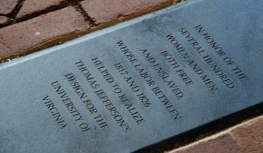HONOR OF THE SEVERAL HUNDRED WOMEN AND MEN,

BOTH FREE AND ENSLAVED, WHOSE LABOR BETWEEN 1817 AND 1826 HELPED TO REALIZE THOMAS

JEFFERSON’S DESIGN FOR THE UNIVERSITY OF VIRGINIA”

It was installed in 2007.

**What was the original Library like?**

* **Location:** Before the Dome Room was completed, the University’s library was housed inPavilion VII.
* **Hours:** For the first year, the librarian only worked an hour a week to receive and retrievestudents’ books.
* **Checking out:** Library regulations limited the number of books a student was allowed to removeto only three (and students had to show proof a professor had assigned the books to them). Students needed to place their requests to the librarian at least a day in advance.
* **Studying:** The Pavilon VII reading room was in the basement, and it was reported to have beenso dark that candles were used to read, even in the daytime.

**When was the Dome Room first used as a Library?**

The Dome Room would not serve its intended purpose until after Jefferson’s death. In October 1826, Rector James Madison noted: “The Library has nearly been completed and the books put in it.” The hours were officially set at 3:30-5:00pm, Monday through Friday.

**PART 2: STORIES**

**“A Revolutionary Reunion”**

**What was the Marquis de Lafayette’s background in America?'**

He was born in France 14 years after Jefferson, an orphan of aristocrats who would inherit one of the country’s largest and most valuable estates. He entered the military at 16, and when the Boy General heard word of the Declaration of Independence, he did something few other self-respecting, incredibly wealthy French noblemen would dare do: he bought a ship, sailed to the United States, and modestly volunteered his military services to the Continental Congress, free of charge. By 20 he trained under Washington, who gave him command to organize a French military force to fight for the Americans.

**What’s Lafayette’s background with Jefferson?**

He met Jefferson during the final year of the war. When Lafayette marched to capture Benedict Arnold, Governor Jefferson wrote Virginia would be “indebted to a nobleman”. When Jefferson had been called a coward for desertion after he and his family escaped Tarleton’s raid on Monticello, Lafayette said “[t]ime will prove that Jefferson has been too severely charged.”

They met again in the salons and streets of Paris when Jefferson was America’s minister to France, as the country headed towards its own revolution. (Jefferson was present when Lafayette saw to the destruction of the Bastille; Lafayette bowed to Jefferson’s daughter as she watched him lead a curtailed Louis XVI through crowded streets.) Jefferson even instructed Lafayette to replace the word “property” with his infamous phrase “the pursuit of happiness” in drafting the *Declaration of the Rights of Man*. Back in America, Thomas Jefferson wrote: “Wherever I am, or ever shall be, I shall be sincere in my friendship to you and your nation.”

**What led to Lafayette’s fall from grace in France?**

Lafayette had been a leader of the revolution, but his continued support for the French monarch led Robespierre to imprison him for five years in Austria. After the Reign of Terror, he returned to France finding his political importance supplanted, his fortune ruined, and many family members guillotined.

**But what was his reputation in America?**

In the almost 50 years since the Revolution Lafayette’s notoriety had endured, and so had his friendship with Jefferson, both of which drew him back to the nation. In 1824, President Monroe and Congress invited him to return to his adopted country, and Lafayette jumped at the chance. It was a highly publicized event throughout the 24 states. As Lafayette was wined and dined in every major city on the East Coast, evidencing what Jefferson called his chief fault: his “canine-appetite for popularity.” Yet Jefferson still wrote to him that “our little village, Charlottesville, also insists on receiving you”, and so Lafayette arrived on November 4, 1824 to reunite with an old friend.

**What was the scene like when Lafayette arrived at Monticello in 1824?'**

He rode in a stagecoach drawn by four horses, leading a 120 man procession. A bugle announced his presence. Three hundred citizens of Charlottesville watched as he walked towards the front door. Lafayette was 67, his health ruined by imprisonment and impoverishment in his native country. Jefferson was 81, rendered frail by more than 40 years of tireless public service. The crowd silenced as the two men approached each other: “Their uncertain gait quickened itself into a shuffling run, and exclaiming, ‘Ah, Jefferson!’ ‘Ah, Lafayette!’ They burst into tears as they embraced each other. Among the 400 men witnessing the scene, there was not a dry eye—no sounds save an occasional suppressed sob.”

“Mr. Jefferson received me with strong emotion,” Lafayette later wrote. “I found him much aged, without doubt, after a separation of 35 years, but bearing marvelously well under his 81 years of age, in full possession of all the vigor of his mind and heart, which he has consecrated to the building of a good and fine university.”

**What was the scene like at the University?**

The University stood new and expectant, but completely empty. Enslaved and free craftsmen had finished the construction of all the buildings (only the Rotunda wanted completion), but at this time they all stood vacant of residents (the first professor coming in a month, the first students in five). Though largely silent on November 4, the next day would be teeming with activity when the citizens of Charlottesville would again gather to attend a dinner in the Dome Room of the uncompleted Rotunda. Records indicate that Jefferson’s original wooden dome was in place for the dinner, but it is likely that there were no glass in the windows or oculus for the school’s first public feast.

**What happened at the dinner?**

Hundreds of residents lined the streets as Lafayette and former Presidents Jefferson and Madison rode down from Monticello to the University. A large flag greeted Lafayette, reading, “Welcome our Country’s Great Friend” from the South side of the Rotunda. From 3-6pm, about 400 guests assembled around tables in the Dome Room. Thirteen official toasts were made for each of the 13 original states, and many more unofficial ones (either due to patriotic enthusiasm, or the chilly November air flowing from the glass-less windows in the Dome Room). Jefferson later wrote: “During General Lafayette’s stay at Monticello, I was obliged to have so much company that we for thro’ our stock of red wine. I expect every day to hear of the arrival of my new annual supply.” This dinner is a demonstration of Jefferson’s *extreme* pride in his University, as it would have been much easier to host the Marquis de Lafayette for two nights at Monticello, but Jefferson insists on showing him U.Va., despite its unfinished nature and his own frail, physical state.

**What were some of the toasts?**

Lafayette toasted: “Charlottesville and her University—an admirable establishment, the immense and ever increasing advantages of which, public and local, her friends are delighted to anticipate.”

Due to advanced age and recent illness (an abscessed tooth), Jefferson could deliver his toast himself, but was read by an official. One section read: “*I joy, my friends, in your joy, inspired by the visit of this our ancient and* *distinguished leader and benefactor. His deeds in the war of independence you have heard and read. They are known to you, and embalmed in your memories and in the pages of faithful history. His deeds in the peace which followed that war, are perhaps not known to you; but I can attest them. When I was stationed in his country, for the purpose of cementing its friendship with ours and of advancing our mutual interests, this friend of both was my most powerful auxiliary and advocate. He made our cause his own, as in truth it was that of his native country also. His influence and connections there were great. All doors of all departments were open to him at all times; to me only formally and at appointed times. In truth, I only held the nail, he drove it. Honor him, then, as your benefactor in peace as well as in war.*” Lafayette reportedly burst into tears. Other toasts touched on the significance of the University, and James Dinsmore (a carpenter for the University) toasted Jefferson, “The Founder of the University of Virginia.” (Note he did not use Jefferson’s own paternalistic term ‘father’, and there is no record Jefferson cried after this toast.)

**Did Lafayette ever return to the University?**

He did return in the summer of 1825 before returning to France. With much less pomp and parade, in August he dined in a completed Rotunda, filled with professors and students (including two of Jefferson’s grandsons). Jefferson was too ill to attend. Before leaving the University, Lafayette was made an honorary member of the Jefferson Literary and Debating Society.

**What did Lafayette say upon learning of Jefferson’s death?**

“I cannot find words to express what I feel,” he wrote. “It is consolation to me to think that both of us have lived long enough to see another once more and to congratulate one another on the marvelous progress accomplished in the United States, and particularly in Virginia, since the time when, as military commander of the State of which he was governor, I met him for the first time in Richmond…”

**The Rotunda Fire of 1895**

**When and why was the Annex built?**

Jefferson's did leave the Lawn open on south end, so that were expansion necessary for additional dormitories or classroom space, his plan would “admit extension” through a repetition of dormitories, colonnades, and pavilions. But this was ultimately impossible. Not only did the topography prevent expansion, but the University did not even own the property; in addition, the setting for higher education had changed from small classrooms to large lecture rooms and laboratory spaces.

Robert Mills’ Annex was opened in 1853 in response to the growing number of students and the University’s need for additional space for classrooms and laboratories. The building offered “4 large lecture rooms, large exhibition rooms, and museum above, all accessible from the Rotunda”.

**Who first noticed the fire, and when?**

It was Sunday morning, October 27, 1895, a bright, cool, clear, autumn day. After skipping church and returning late from breakfast at a nearby boarding house, a student named Mason Foshee, a second-year from Brewton, Alabama, was on his way to Fayerweather Gymnasium to work out when he noticed thin curls of smoke issuing from the north ventilator of the Annex (a building attached to the Rotunda and projecting toward Main Street). Unnerved, he hailed two more students nearby, Sloan and Penton. The three students hastened and, breathless, found the janitor Henry Martin to have him ring the Rotunda’s bell and spread the alarm. Martin’s prolonged ringing aroused the attention of the entire University community, after realizing it was not merely the signal for morning chapel services. The bell and shouts of “Fire!” soon enlightened everyone to the state of affairs. It was 10:15am.

**What action did the community take to try and stop the fire?**

There was considerable confusion as students emerged from dorms, shouting and running. Professor Minor and a mob of students ran to suck water from the pond between the chapel and the road (about 50 yards west of the Annex) using an engine from the West Range, but lacked the suction pipe to do so. A fire hose was then attached to the nearest fire plug (halfway between Madison Hall and the end of the Annex) and dragged up the high, narrow steps leading to the rear door of the Annex. As firefighters entered the Annex’s Public Hall, they found a fire raging in the rooms of the Engineering Department (the northwest corner of the Annex, above the Public Hall). They pulled up the hose and… it could only produce a stream of about five feet, insufficient to reach the ceiling.

In the drawing room above the Public Hall, there was a bucket brigade attempt, but it was forced back by dense clouds of choking smoke. To save the Public Hall’s valuable 30x15 foot painting “School of Athens”, Mathematics Professor William H. “Reddy” Echols (who had received his Bachelors in Civil Engineering from the University) and a number of students attempted to check the spread of the flames across the ceiling. But the flames consumed the beams supporting the lights and reflectors above the stage, sending them down with a crash, followed by sparks and large burning brands.

The firefighters were forced by out of the Public Hall, left, in the words of Professor Humphries, “to take up another line of defense.”

**When the community realized they couldn’t stop the fire, what did they resort to?**

When all attempts to check the spread of the flames within the Annex failed, Professor Echols grew concerned the fire might spread to the Rotunda itself (and thus the library) across the portico of four pillars connecting the Rotunda to the Annex (circled in two different views below).

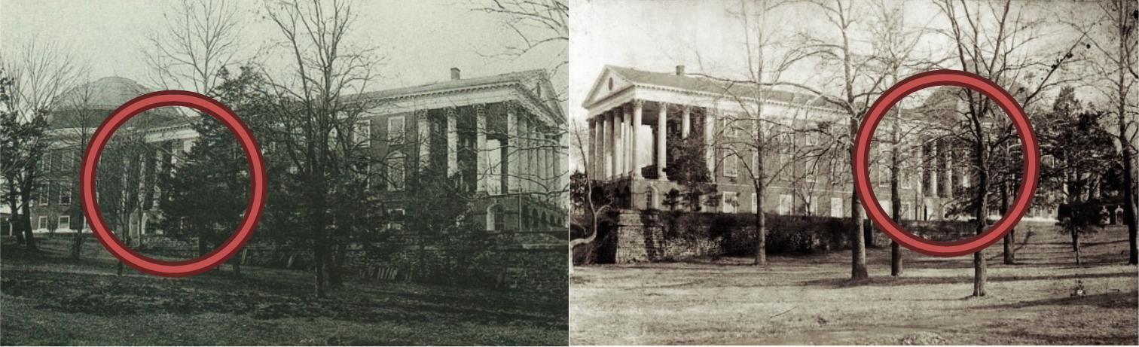

Rotunda and Annex from the Rotunda and Annex from the

West (Brooks-side) East (Chapel-side)

While students began removing engineering instruments and volumes from the law library to safety, Professor Echols decided to blow up the bridge connecting the Annex to the Rotunda. J.A. Bishop, conservator of peace at the University, brought up a hundred pounds of dynamite from his shop, Echols and a few others proceeded to blow down the four columns holding up the portico.

But the firm roof obstinately refused to fall. Flames from the burning Annex were licking the roof—the fate of the Rotunda depended on its destruction. Echols was determined to blast down the roof, now from above, from the dome of the Rotunda itself. After securing two more 25 lb. boxes of dynamite from town, Echols violently split open the boxes with an axe, dumped their contents into a meal bag, hustled up the dome and coolly hurled all 50 pounds of dynamite onto the connecting roof.

The resulting explosion was terrific, heard from 15 miles away, shattering all the Rotunda’s windows, and causing the dome’s plaster ceiling to come crashing down. But the connecting roof was still not completely destroyed, and the menacing flames advanced to the Rotunda.

**While Echols tried to blow up the portico, what were students doing?**

Meanwhile, many students and local women began removing the books and paintings from the library in anticipation of the advancing flames, smashing the bookcases’ glass doors, carrying books in arms and skirts to the nearest windows, and dropping them onto blankets and sheets held by those below. This work inspired some ambitious students to rescue the larger paintings and sculptures about the Rotunda. All the important paintings were removed.

Another group was securing ropes to save the Galt statue of Jefferson in the Dome Room. Students developed a pulley system using the ropes and the pillars of the gallery level to lower the statue to a horizontal position onto a table, but the table collapsed under the statue’s weight, chipping Jefferson’s cloak in the process.

As smoke and flames and hurried students filled the room, the statue was rolled onto its back and hauled across the library to the staircase, shoving it down until it jammed at the turn of the narrow platform. They were able to free the statue and lower it down the western stairs, feet first, step by step, the base tearing the top edges of each step as it passed. Once down, the statue was dragged and pushed onto the south portico, then slid down the steps to the Lawn on a series of Lawn room mattresses.

It was then covered by a blanket for protection, before being moved to Brooks Hall for temporary keeping. The whole operation consumed about ten or fifteen minutes.

**What prevented the rest of the Lawn from burning down?**

With both the Annex and Rotunda entirely consumed in flames, firefights turned their attention to saving the Academical Village. As the flames reached the Rotunda clock, stopping the hands at 11:55am, soaked Lawn room blankets had been draped over the ends of Pavilions I and II to keep the fire from spreading. Bucket brigades kept the roofs of both buildings constantly wet. Echols, meanwhile, was still at it with the dynamite, blowing up either side of the blazing Rotunda (this time, falling through the roof of one room, breaking his left hand).

The entire population of both Charlottesville and the University were involved in the firefighting. And as the flames continued, many in their Sunday best watched over it like a funeral service.

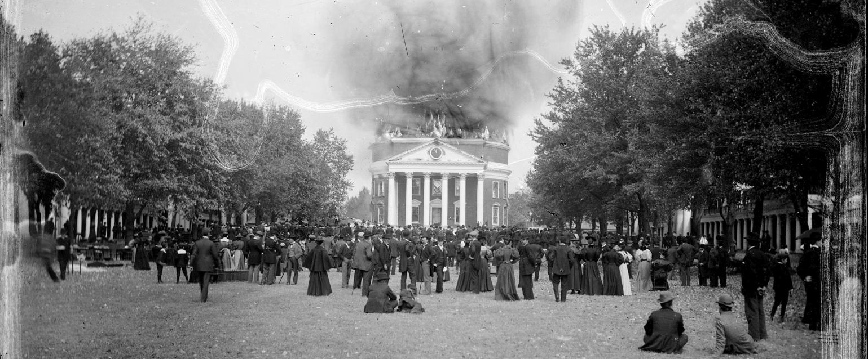

About this time, however, nature intervened to save the University from future conflagration. The winds shifted and began blowing from the south, thus diverting the advance of the fire away from the Lawn. At 1pm, the dome and inner framework of the Rotunda collapsed, quickly followed by the old bell onto the south portico, landing with a loud clang to signal the end of a losing battle with the flames. By 2:30pm, it was all over: the Rotunda and Annex were left to smolder.

Telegrams were sent to Staunton, Lynchburg, and Richmond for help. The Staunton Fire Company arrived to help, and the Lynchburg Company came later, but the Richmond Department was notified on their way that the danger had past so they returned homeward.

**What do we think caused the fire?**

No one is certain, but it’s suspected that either faulty electrical or trolley system wiring, which was very new for the time, in the Annex might have sparked it.

**How many books were saved?**

The fire was perhaps most devastating to the library, which had grown sevenfold in seventy years, from about 8,000 to 56,733 volumes, only to see its holdings reduced to 17,194 volumes in a single day. Only 11,694 were saved; the rest were destroyed.

**What remained of the Rotunda and the Annex?**

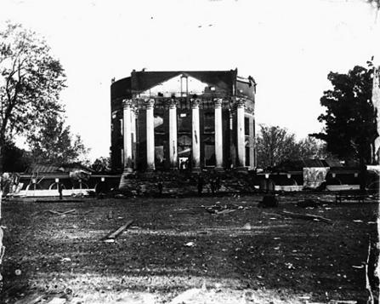The Rotunda was a charred, hollowed shell, with only its outer walls remaining intact. The Annex and nearly everything in it had been totally lost. Total damage was estimated at about $175,000 (on property insured for only $25,000).

**With the Annex gone, how soon did classes start up again?**

Organizations and faculty surrendered their halls and offices and apartments for instruction. The faculty met immediately to arrange a new schedule of lectures and lecture-rooms, and at 9:00 that Monday morning *(the next day!)* the routine of instruction continued.

**What remains today from the Annex?**

Today, all that remains of the old Annex is the high terrace and grassy mound upon which the old building once stood. The old Corinthian capitals are now scattered about Grounds; two are hidden by shrubbery in front of the Fralin Art Museum, others located inconspicuously around Lambeth Field and pavilion gardens.

**How soon was reconstruction planned?**

Less than three months later, on January 18, 1896, Stanford White† was engaged to draw up plans for a redesigned Rotunda and buildings to replace the destroyed Annex. Thus Rouss, Cocke, and Cabell Halls closed off the end of the Lawn by 1898. The new University sprang up from the ashes of the old, in time to greet the new century.White is famous for designing one of the first incarnations of Madison Square Garden in New York, and for being murdered on its roof by the husband of a woman he was having an affair with.

**After the Fire**

**How did the faculty react to the challenge posed by the fire?**

They considered the future: rising a phoenix from the ashes, rebuilding the University. The details are complicated, but some observations can be made:

*1. Architecture is integral to the University’s identity.* Our identity is constructed around this space andthese buildings; its quality makes us different from other institutions. So when this was threatened, the University turned to the country’s leading architects: the New York firm of **McKim, Mead and White**. **Stanford White** of that firm possessed amazing talents, the best of that generation. The Universityauthorities knew good architecture was of supreme importance.

*2. Jefferson’s designs needed revisions.* The University recognized, considering the fire, his scheme forthe University was outmoded in several respects. Jefferson created an institution for 200 young men; by the mid-1890s the student population stood at about 550, and collegiate education differed considerably from Jefferson’s model. New facilities with different types of spaces: large laboratories and lecture halls were needed. Jefferson's library in the Rotunda, powerful symbolically -- overflowed, with no room to expand. How do you add to a circle? Jefferson’s sketchy plan for enlarging the grounds was “by extension”; the duplication of a continuing line of dormitory rooms and pavilions which would have us stretching to Lynchburg by now.

The difficulties with Jefferson’s model can be observed in the Grounds prior to the fire. A reorientation of Jefferson’s plan had occurred. With the additions of the Annex (1853), Brooks Hall (1876), the Chapel (1889), and Fayerweather (1893), instead of entering the Grounds from the south end and progressing towards the Rotunda – as Jefferson had intended – most people came from the north, the rear so to speak.

*3. How would the space of the Lawn change?* Stanford White made two proposals for the addition ofnew academic buildings. The other was to site them not across the end (what called “the most natural and architectural” option), but off to the side of the Lawn (what he called “the most practical” option). Even White noted, “We should regret blocking the beautiful vista at the end of the present campus.”

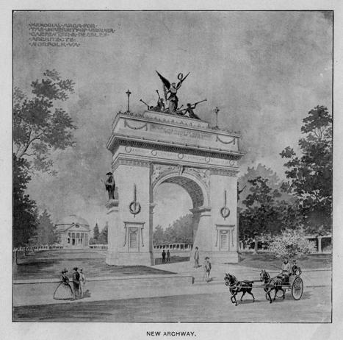

After deliberations, Rector William C. N. Randolph (Jefferson’s great-grandson) directed White to locate the buildings at the south end of the Lawn, closing off the near view to the southwest. (Stanford White’s agreement, despite his respect for Jefferson’s architecture, gives rise to the observation that architects are frequently not their own masters.)

It remains unclear what Jefferson’s intentions were for the south end of the Lawn. What is more evident is that there was, throughout the 19th century, a discomfort with the openness of it. Over the years, there were multiple attempts to close it off: proposed statues of Jefferson, buildings, chapels, even a triumphal arch commemorating

Confederate soldiers (seen above, with the Rotunda in the background), all at the end of the Lawn. In fact, using the south as the main entry had never worked very well; the slope of the hill was often impossible to traverse in inclement weather. And in addition to desiring a new, more natural northern entry, Rector Randolph and many faculty wanted to block a view of the unsightly houses that had sprung up along the road to the south, some of which were inhabited by African-Americans.

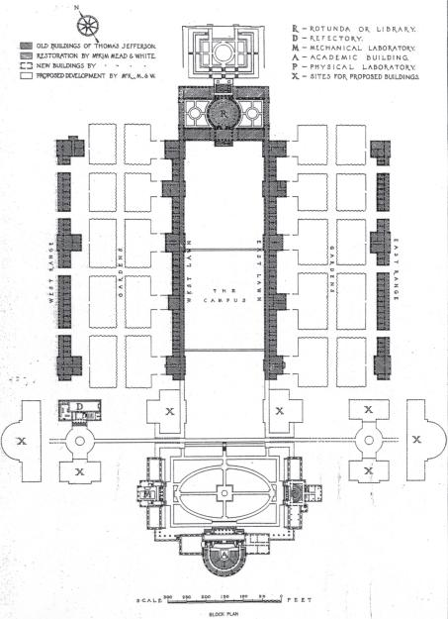

Arguably, White’s placement of Cabell saved the Lawn: White turned the focus from outward into the space itself, though he did attempt to preserve the distant view by sinking Cabell Hall. (You can see the McKim, Meade and White plan for closing the south Lawn at right, as well as for other buildings that were never built.‡)!

White’s design for Cabell Hall shows his recognition of the space of the Lawn as central. The volume of the auditorium in Cabell Hall is one quarter of the Rotunda’s sphere. On the interior, facing the Rotunda, White placed a

copy of Raphael’s “School of Athens”, duplicating the one destroyed in the fire (which you can see in the section “The Rotunda Fire of 1895”). One enters on either side, turns and sits facing the “School of Athens.” Its two central figures, Plato and Aristotle, stride toward you from the Rotunda. In form and iconography White’s design for Cabell Hall focused attention back to the great central space of the Rotunda.§

*4.What opportunities did the new buildings present for the University?* The new buildings, Cabell,Rouss (for physics), Cocke (for engineering), and the rebuilt Rotunda allowed it to compete with the larger (and richer) northern institutions. In spite of Jefferson’s grand national ambitions for the University – to equal Harvard and Yale, for instance – it had not achieved that stature. The library was pitifully small in comparison with the others, and the fire had decimated it. Yes, we stood tall in the South, but nationally, we were second-rate. The new buildings marked the re-emergence of the University on the national stage.

*5. What would the new Rotunda look like and be used for?* Conflict revolved around Stanford White’sdesign for the University library in the Rotunda. He sought an aesthetically dramatic solution and made one great space resembling the Pantheon in Rome, Jefferson’s original model:

*"Only one deviation from the original plan has been made, but this is one which Jefferson would unquestionably have adopted himself had he been able to do so when the Rotunda was built, and one which he would have himself insisted upon still more, could he have directed the*

*restoration."*

The firm prepared this plan for future expansion of the University that envisioned a Beaux-Arts grouping of buildings at the south end on a cross axis. To some degree a few structures such as Randall Hall, 1899, and Minor Hall, 1911, followed this scheme, but later buildings turned their backs on the Lawn.

§ Fun fact about Cabell Hall: The models for the figures in the pediment of Cabell Hall were recruited from the local bordello [brothel] when the sculptor George Zolnay could not convince any Charlottesville ladies to pose in the nude.

White argued that for utilitarian reasons, Jefferson had divided the interior into two floors, but he had really desired for the Library to be a single floor, two-stories high (like the Pantheon); hence in his mind, White was merely respecting what Jefferson could not accomplish.

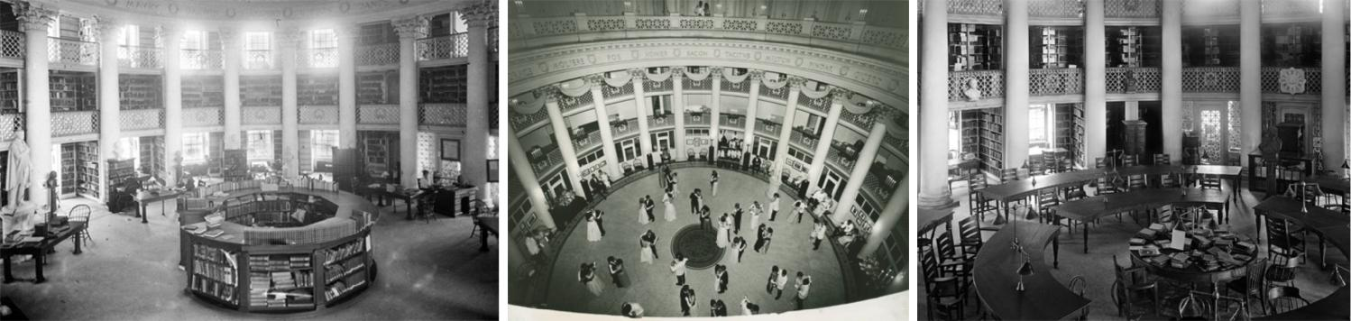

He maintained the Rotunda as the library, although it became overcrowded and moved to the new Alderman Library in 1938 (a WPA-era project during the Great Depression).

**What happened as a result of the new buildings?**

This process did not go smoothly. The faculty and the Board feuded and construction was ragged. The mess caused the University to shift from Jefferson’s loose management to instating our first President. (Woodrow Wilson was first approached before Edwin Alderman was inaugurated in 1904.) The intent being to allow faculty to do what they do best: teach and research, not be concerned with management.

**What’s to become of the Academical Village?**

The removal of the library from the Rotunda in 1938 made the building redundant. Though restored in the ‘70s to the Jefferson configuration, it still sits there a hollow symbol used for dinners, dances, and the occasional talk. I won’t propose what should be done, but note that the emptiness of the Rotunda speaks of a greater issue: **that architecture can lose meaning with loss of purpose**.

Imagine the Academical Village on October 27, 2095. Will our new buildings be held in high regard? More significantly, will our successors need this place at all? Victor Hugo, in *Notre Dame de Paris*, argued the printed book replaced architecture as the permanent record of mankind. Perhaps cyberspace, or whatever new technology of the future, may threaten its replacement as well. And these values of online interconnectedness may be at odds with the spirit of personal interchange and activity that is central to the Academical Village. (Certainly in 2095 the Academical Village will exist in “Virtual Reality,” or one can visit and take a tour orchestrated by some giant corporation that will reenact the fire. Such a chilling scene will never come to pass -- we hope.**)

**Why is the architecture of the University important to preserve?**

People are personified by the buildings they inhabit. Architecture is created by people acting as either individually or in concert, and buildings do more than contain activities, they shape and inspire ideals. To Jefferson, architecture, the institution and the purpose of the university were one: they were inseparable. After the fire, the faculty and the Board of Visitors possessed the good sense to realize architecture was the medium for renewal. Today, we are an international institution with a reputation to match, but we are still rooted here. It is our job not to create the Jefferson look but to meaningfully continue his intentions and ensure that 100 years from now this will still be a village in which important intellectual activities take place.

**The 1976 Rotunda Restoration**

**What happened to the Stanford White Rotunda?**

The entire library collection was moved to Alderman Library in 1938. The Rotunda became a place for the display of a limited collection of artifacts, minor administrative offices, a starting point for guided tours, and the occasional ball or reception. It stood more as a monument to the past than as the central building of the university.

Because of this, relatively limited modifications or maintenance was conducted to repair the ravages of time on the Rotunda. During major expansion and increasing enrollment following World War II, further work on the Rotunda was overlooked in favor of new construction for other purposes.

**When did the idea for restoring the Rotunda begin?**

When President Colgate W. Darden, Jr. asked Professor Frederick D. Nichols in 1955 to advise him on ways to enlarge Pavilion VIII (then the office of the president) to house an expanded executive staff, Nichols had already been studying Jefferson’s drawings, engaged in efforts to restore the pavilions and gardens of the Lawn. So he proposed instead that the Rotunda be returned to the Jeffersonian design, which would yield the adequate space for the offices President Darden was then seeking. (Nichols reports that Darden was shocked to learn that the Rotunda, as he knew it, was not that of Jefferson, which was evidently a prevalent view in the university community.)

Nichols drew up new plans, reversing the design approved in 1895. Original designated as a library and shaped on the interior to suit, Nichols proposed that the structure be resorted and suitable uses be found for the rest of the resulting building. He was confident that the building could once again become central to the life of the university, by placing the offices of the president, his staff, and the Board of Visitors in the building… rather than an empty shell.

**What questions were raised in planning the restoration?**

There were questions about the structural safety of the Dome, how to install a waterproof skylight, the type of floor wood, the cornices and furnishings of each room, how to install A/C and an elevator… we’ll outline three of the major decisions here.

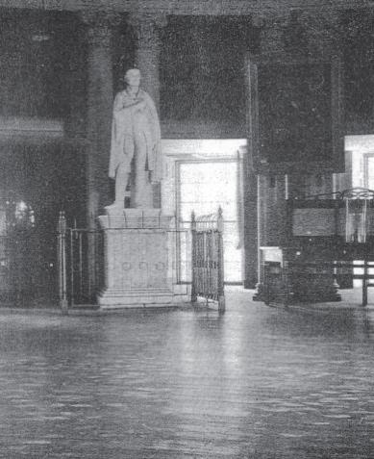

**How did they know which direction the floorboards should be?**

After much debate about the merits of each direction (there were no original drawings or notes showing how it had been done), an old photograph of the Dome Room (seen left) settled the question, showing the direction as being from east to west (fireplace to fireplace).

The University Bookstore manager actually lent the photograph to the reconstruction committee, having purchased it from an auction, not knowing the search was underway to find this particular detail. The search had begun long before construction began, and the answer found after construction was already underway (although *before* the time had come to actually lay the floors).

**How did they decide the pattern of bricks for the basement floor?**

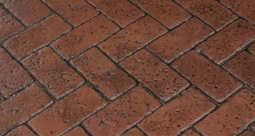Conventional squares? Herringbone pattern? Another? Extensive research was inconclusive, and after the usual debates, a decision had been made to lay them in a square pattern. On the morning when actual work was ready to begin, a workman – clearing out an edge as a starting point – discovered a small section of old brick floor laid in a herringbone pattern. A hurried conference of the committee concluded that the original plan should be followed, and within minutes the work was underway using the herringbone pattern.

**How did they decide on the color of the roof?**

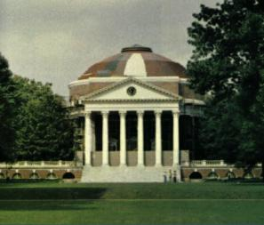The color of the roof raised questions and controversies and gave occasional moments of humor. Some committee members wanted the soft green of Stanford White’s roof to be used again. To settle the question, the architect arranged a display of suggested colors, somewhat to the astonishment of passersby. The committee decided on white because it was attractive from a distance and had most likely been Jefferson’s choice, since he had purchased only white paint for the university buildings while the Rotunda was under construction.

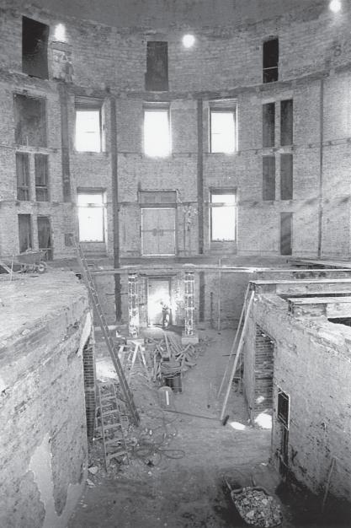

**How often did these types of decisions take place?**

These stories show how deeply each party seemed to feel a personal responsibility to get the task right. The committee was consulted on decisions about details “sometimes two or three times a day”. It was frequently difficult to tell in advance which decisions were minor, with simple consequences, and which had major implications. Some could be planned well in advance, but others required quick response to avoid interruption of the work schedule.

**How long did the construction take?**

Starting in 1973 until its re-opening ceremony on April 13, 1976 (on Thomas Jefferson’s birthday in the year of the nation’s bicentennial). To those who had literally spent years of their lives planning and hoping for the restoration, the moment of completion was overwhelming; there the Rotunda was, just as Jefferson had conceived and built it.

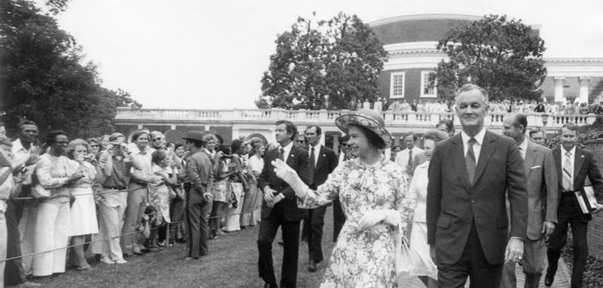Queen Elizabeth II of England and her husband Prince Philip visited at a luncheon in the Dome Room on July 10, 1976. 18,000 people gathered on the Lawn to greet the royal couple.

The Queen spoke of the longstanding partnership between Britain and America, which “has its roots here in Virginia.” Facing the Rotunda, the Queen said: “It is a moving experience to stand amidst the beauty he [Jefferson] created at this University.”

**What happened when Elizabeth Taylor visited in 1977?'**

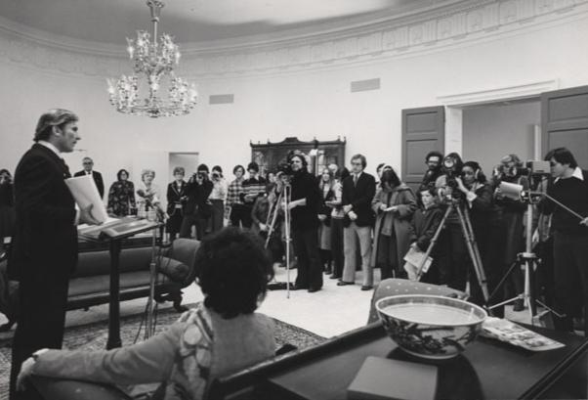Taylor’s then-husband U.S. Senator John Warner had retired as Secretary of the Navy and had came to donate his official papers to us. During a reception in the West Oval Room, Warner was speaking at a podium when Elizabeth Taylor sat down on the off-limits antique Duncan!Phyfe couch. The Rotunda Hostess frowned but could say nothing as President Hereford sat down beside Taylor.

**What has the building ultimately been used for?**

Though initially planned as an administrative building, President Hereford decided against moving offices to the Rotunda, thus releasing space for more varied activities: Museum shows, receptions, initiations, and room for studying in the Dome Room; Board meetings in the East Oval Room; Doctoral defenses in the North Oval Room; reception for the President’s guests in the West Oval Room; a museum of artifacts in the basement rooms; and the Vice Presidents’ offices in the basement wings.

The restored Rotunda attracted about 900 visitors daily, coming to see Jefferson’s last monumental building. Two years after the dedication ceremony, the building was once again considered the symbolic center of the Academical Village. A student paid tribute in 1976:

*The Rotunda has been burned, dynamited, shot at, and bled upon. It has been stuffed with books, jammed full of students, gutted twice and restored three times since Mr. Jefferson’s plans for “something of the grand kind” as a centerpiece of his academical village were translated into brick and mortar in the spring of 1823. Through reconstruction, renovation, and adaptation, however, the building has remained the spiritual and architectural focal point of the University. The Jeffersonian ideal of a synthesis between beauty and functionality was, and some say, still is, the guiding light for construction of the entire University and especially the Rotunda.*

**What’s ironic about this sentiment?**

It didn’t work. Even today, during the Rotunda’s ongoing renovations, one of the clear motivations is what administrators and architects have been trying to achieve for the decades since the Library left the building. “One of the real goals of this project is to make this building one that you walk into, not walk past,” says Brian Hogg, Senior Historic Preservation Planner. Maybe this time it’ll actually work.

**2012-2016 Rotunda Renovations**

**What was completed during the first phase of construction from 2012-2013?**

The first phase replaced the steel panels that once covered the dome with a copper roof. (The plan to paint the copper roof white during April 2013 was postponed due to rain, and could not be done during the summer months due to the heat.) It also replaced the leaking roof and installed a new glass oculus. Additionally, they repaired the external brick walls of the Rotunda’s cylindrical drum, its windows and ornamental sheet metal.

**What was done during the final phase of renovations from 2014-2016?'**

Starting after graduation in 2014, the second phase has required two years of almost constant construction work. (This work focused primarily on interior improvements, mostly structural and functional ones, but one big aesthetic improvement).

* **Refurbished mechanical, electrical, and plumbing systems** were installed. They createdadditional underground space for this infrastructure and for catering operations.
* **Handicap access** will improve with a new widened elevator with access from the inside, and awheelchair lift to provide access to the terrace level outside. The elevator is housed on the East side of the Lower Hallway (towards the South end of the hallway) and can be operated without an attendant, if you ever need to give a handicap-accessible tour.
* **Office space** on the Rotunda wings expanded into the space underneath the South steps of theRotunda (Lawn-side).
* **New audiovisual equipment**, like projector screens in each of the room’s ceilings, was put ineach of the rooms for more classroom opportunities.
* **The Dome Room** has new panels on the interior of the dome, as well as a cable-operatedcloth shade under the oculus to cover the window during audio-visual presentations. There is also now a public-access staircase to the gallery encircling the upper perimeter of the room that provides visitors with close views of the room’s new Composite capitals carved of mahogany in Richmond (also this balcony has some sweet study spots).
* **The North Oval Room** will be available on The Source for student study groups to reserve, likethe study rooms in Clark.
* **The West Oval Room, Main Floor** (previously called the President’s Reception Room) has been redone as a student study space with lots of nice furniture to encourage more students to visit.
* Most importantly, **the Corinthian capitals** on the Rotunda’s exterior were replaced in May 2015.

“The whole idea is to get more University functions, more student functions into the building, and we’re doing all we can to set it up for that,” said Jody Lahendro, historic preservation architect for Facilities Management.

“One of the real goals of this project is to make this building one that you walk into, not walk past,” said Brian Hogg.

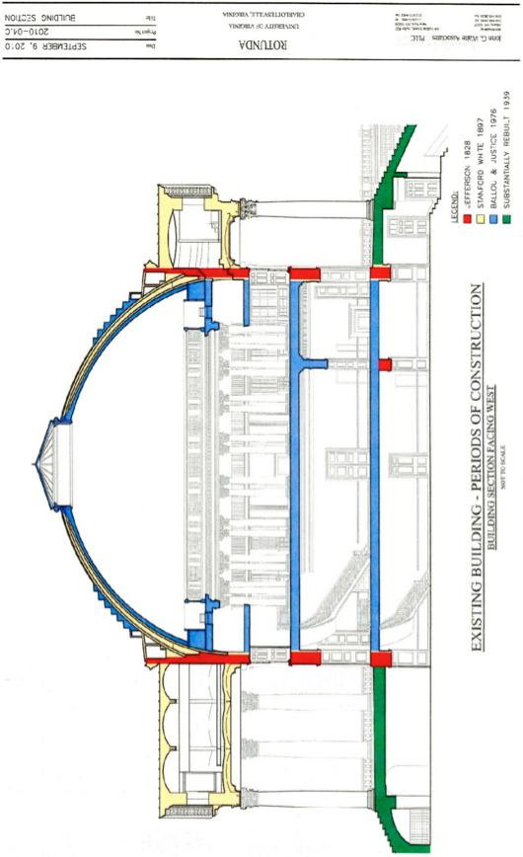

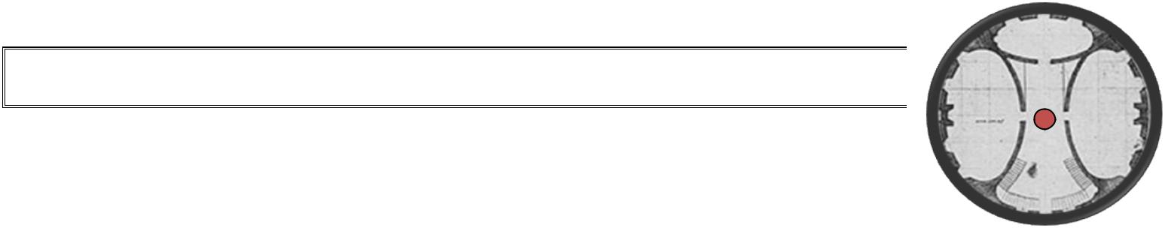**PART 3: THE ROTUNDA, ROOM BY ROOM**

**The Lower Hourglass Hallway**

The bricks are laid in a Herringbone pattern, a design literally decided the day repaving was scheduled to begin.

**Medway Bell (with an exhibit on Henry Martin)**

* This 416-pound iron bell was cast in Medway, Massachusetts in 1826 by Paul Revere’s apprentice George H. Holbrook (one of the 11,000 bells he produced).
* 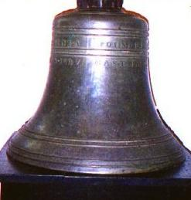Visitors can touch the bell. It is one of the few artifacts from Jefferson’s original Rotunda, hung above the Rotunda’s southern portico.
* Jefferson ordered that the ringing of the bell be heard across Charlottesville, two miles away. Its ringing awakened students to call them to classes and kept time for all residents.
* The bell rests on the same table as the one in the picture of Henry Martin in the exhibit next to it.

*The Bell Ringers:*

**Lewis Commodore**, a slave purchased by the University, rang the bell after 1832. **Henry Martin**, afreed African-American who began life as a slave, rang the bell for 53 years, from 1856 until his retirement in 1909.

Martin says he rang the bell at 4 A.M. each morning before the Civil War, and at 4:30 and at 5a.m. after the war. (This early rising rule was an early source of tension between students and the administration.)

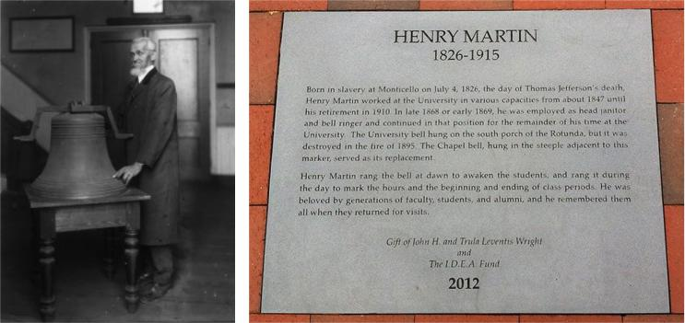

Martin prided himself on keeping the University running like clockwork, but confessed in the 1914

*Corks & Curls*, “I did miss one morning. Right after the Surrender, the students climbed up and turnedthe bell over and poured it full of water. They didn’t mean no disrespect to the bell, but it froze and cracked. They got me a new bell then, but it ain’t never sounded like the old one…” The bell’s crack is on the inside. It was soon replaced.

Martin prided himself on a repertoire of rings, each one distinct, depending on the message it carried. “This bell they got now, it sound just the same for a funeral as for a game of football,” he said, “but when I rang it everybody knew what I was ringin’ it for.”

After it was retired, the bell spent many decades cellar-hopping (from a coal cellar under the Rotunda, to Brooks Museum shortly before the fire, to the basement of Bayley Art Museum in 1948) before being lost for several years. It was the Guide Service who actually found the bell again in 1964 in the basement of Clark Hall, and its identity as the true Medway Bell was confirmed.

A plaque in honor of Henry Martin’s service to the University was dedicated in 2012, located by the Chapel.

**Pendulum Clock:** This clock, encased in mahogany, is dated from around1790-1810 and is the oldest piece in the Rotunda. It features a painted metal face with a moon dial and the day of the month. William Barton Rogers, professor of natural philosophy from 1835-1853 (and eventual founder of MIT) purchased it in 1861. The clock, which originally stood in Pavilion IV, was ‘lost’ in a closet of the Physics Building for about 15 years. After a refurbishing, it was brought to the Rotunda in 1983.

**Windsor Chairs & Benches:** These pine seats were made in Virginia in 1970,then painted Spanish brown. These chairs represent an ingenious design principle—the legs, arms, and backs all penetrate a single, thick board that serves as the seat. They are based on designs from the Queen Anne period (early 1700s), and are replicas of chairs and benches that would have been found in early Rotunda classrooms.

**Tanner-Boye Map (Located on the West wall)**

* Henry S. Tanner did this engraving of Henry Boye’s map in 1826, donated in 1977, now framed in three sections at the Rotunda.
* 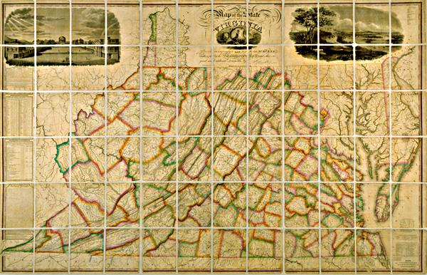The map is divided along rectangle sections, indicating a day’s distance on horseback.
* The upper left hand corner of the map features one of the earliest views of the Academical Village. It’s so precise that the Rotunda, Lawn, and Pavilions—even a slavewoman holding a white child on the balcony of Pavilion IX—are visible. An enlarged version of this depiction (separate from the rest of the map) can be found on the back wall of the Lower East Oval Room.
* The very left displays an immensely detailed statistical table, geographical remarks, and a Table of the Population that counts the

“Whites”, “Slaves”, and “Free Blacks” in the state of Virginia.

* It includes what is now West Virginia, so many guides will point out that the Virginia General Assembly partly chose Charlottesville as home for the state University because it was exactly 3 miles to the geographical center of the what was Virginia at the time.
* The engraving above each section can be interpreted as representing an important facet of Jefferson’s personality: **the University** shows Jefferson the educator, **the Natural Bridge** shows Jefferson the naturalist, and **the Virginia Capitol Building** shows Jefferson the statesman.

**The Lower West Oval Room**

This room will serve as a classroom on Mondays, Tuesdays, and Wednesdays throughout the academic year for COLA’s and seminars. Therefore, do not open the door to let your tourists “peek in” on this room on those days. It will also serve as an additional meeting space for student organizations. This all lies very much in line with the purpose of the most recent renovation in which the Rotunda was meant to be more student-accessible.

From a historical perspective, however, there is very little that is special about the Lower West Oval Room. There are no artifacts of note inside Lower West Oval Room, so assure your tourists they aren’t missing out on much. You can say that the Oval rooms are mirror images of one another (including the dividing pillars which will be explained later) and that the room was a natural sciences classroom in the University’s early day.

**The Lower East Oval Room**

The Lower East Oval room houses an exhibit of Rotunda and University history, displayed on the walls. Historical tours begin here. (There are several great photographs found on the panel exhibits around the room guides can use to supplement their tour stop.) Because of the renovation, this room is now a refreshed and reinvigorated visitors center, with new displays and interactive kiosks.

**Maverick Engraving (in a panel of exhibits)**

* This is a reproduction of the 1822 original copperplate completed by Peter Maverick, the first map/print of the Academical Village produced and executed from Jefferson's drawing/design.
* 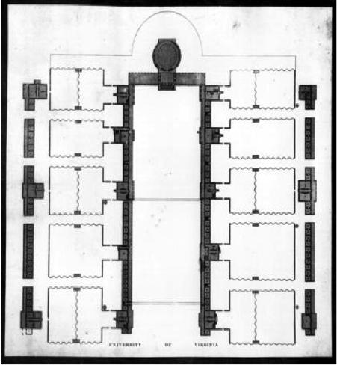An 1825 ‘recruitment’ map of this design was sent to prospective students (much as we send view books today) so that they could see the layout of the Grounds. The Maverick Plan provided the public's first visual knowledge of the University.
* Note that the engraving is slightly inaccurate, however; the image is the idealized depiction of the University, as this was commissioned in 1822 but construction was not finished until 1826. At the time, Jefferson was still very much figuring out what to do with the Gardens, in particular. Based on archaeological evidence, it was established that in Gardens without a hotel (3, 7, 4, and 8), the Garden walls were a bit closer to the Range rooms than they are today, so as to give the hotelkeepers more direct access to students’ rooms. When the Garden Club of Virginia took to restoring and beautifying the Gardens in the 1950’s, they took the Maverick Engraving as their reference for the outline of the walls, though the Gardens never actually held that design in the 1800’s. So, basically the Garden walls are off by a couple of feet from their original design in a few places, but in line with the pre-construction ideal.

*Discussion Points on the Maverick Engraving:*

It reveals Jefferson’s innovative design for his university, believing “Large houses are always ugly, inconvenient, exposed to the accident of fire, and bad in case of infection. A plain small house for the school and lodging for each professor is best…in fact a University should not be a house but a village.”

In the back of Jefferson’s mind was his distaste for the layout of his own alma mater, William and Mary, but it did encourage what he liked best about his own college experience: students interacting with their faculty both in and out of the classroom. (Feel free to use Quotes from the Jefferson section on William and Mary to highlight his aversion for its set-up.)

He also put the library at the center, the first American university not centered around a chapel or a church, which was controversial. Also notice the south end was left completely open, likely with the intention of expansion.

I also talk about how the blank edges of the Engraving reveal how isolated UVa was (Charlottesville at that time being a few miles away), and how we should approach UVa as a largely self-sufficient plantation. This is a good way to get slavery into your tour early so it’s not jarring and excluded to one stop.

A huge reason Jefferson founded the University was his belief that freedom could only be preserved by an enlightened populace; in 1805, while initially planning a university, he wrote: “I have looked on our present state of liberty as a short-lived possession unless the mass of the people could be informed to a certain degree.” He even let students study whatever disciplines they found interesting. *And yet, one should remember that Jefferson’s educational intent included only a select portion of the population and excluded women and non-whites*. Only the most talented and privileged of young men would proceed to the University. His was not the wider freedom of opportunity for all that we have come to expect in the twentieth century.

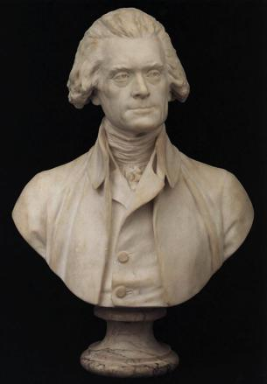**Houdon Bust of Jefferson**

* Plaster replica cast from the 1789 original (which many will have seen at Monticello) carved by the famous French sculptor Jean Antoine Houdon while Jefferson was residing in Paris as foreign minister to France at the age of 46. It was cast from real-life, so it’s quite close to Jefferson’s image at the time.
* This is one of the most famous images of Jefferson: it was basis for the image of Jefferson found on the pre-2006 nickel.

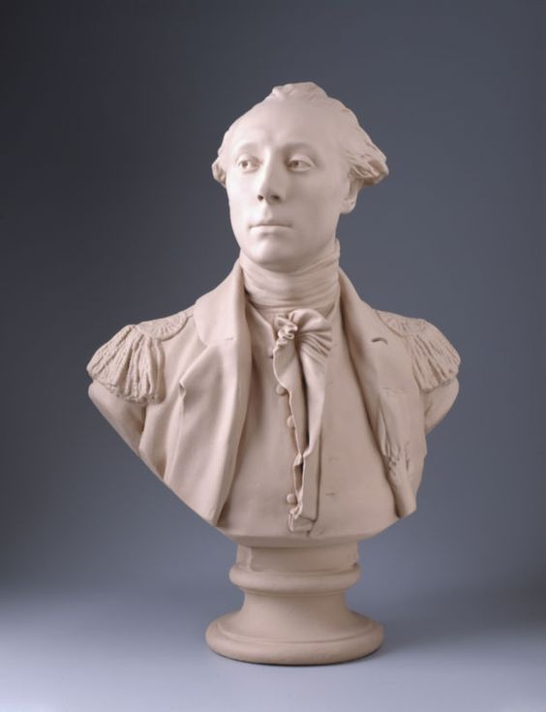

**Houdon Bust of Lafayette**

* The porcelain bust of Lafayette is a copy of the original by Jean-Antoine Houdon, donated by the French government in 1903 or 1904 to commemorate the 1824 Rotunda dinner and in celebration of the Jefferson-Lafayette friendship.
* Lafayette was the first official visitor to the (then unfinished) Rotunda.

**Chemistry Ovens**

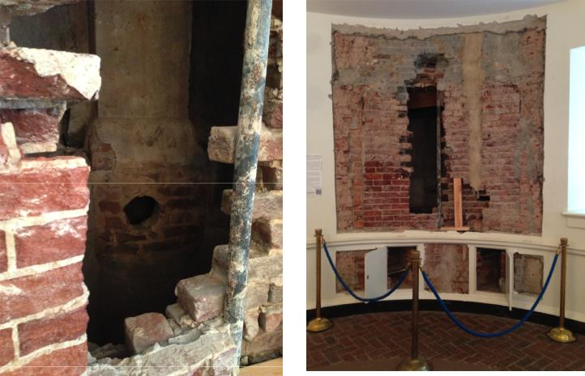

* The two small ovens were discovered during the 1970s restoration, confirming the lower east oval room was the site of early chemistry classes. The larger furnace was found during the 2013 restoration.
* Likely been walled off since 1853 when the chemistry operations moved to the Annex.
* These ovens also once produced saltpeter, used in making gunpowder for the Confederacy, as the University was one of

only two colleges to remain open in Virginia throughout the Civil War (the other being VMI).

**The Bohn print of “UVA from West” (in a panel in one of the exhibits):**

* This 1856 lithograph of UVA is from the perspective of Lewis Mountain. It depicts theUniversity shortly after the completion of the Rotunda Annex (1854), which is unfortunately partially cut off in the panel. The Bohn print can serve as a platform to talk about the Annex and the need for additional classroom space at a growing university as a transition into a telling of the Great Rotunda Fire of 1895. Or you could point to the relative separation of the University from the City of Charlottesville, even in 1856, which turns out to be important less than a decade later when UVA is saved, but much of Charlottesville is burned in the American Civil War. And if you are interested in structures that are no longer here, you can point out the small parapet in front of Hotel E that we found evidence of in 2003 or the Anatomical Theatre in the fore of the print.

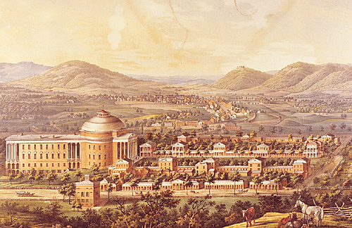

**Pillar Markings in the Floor**

* There are now markers in the floor showing the footings for two posts that were in the room. We found a text reference to “pillars” in both the Lower Oval rooms, then the footings for them during archaeology. These make sense – it would have been hard to have a span as wide as these rooms (the footings were in both lower oval rooms) in Jefferson’s time. We don’t know if there were similar columns/posts in the two large upper oval rooms, but there may well have been. With this new information, we can more accurately envision how classes may have been set up in the oval rooms with two pillars in the middle of the room.

**Astronomical Clock**

* UVA purchased this late 18th century Parkinson & Frodsham clock in London in 1827 with the intention of establishing an astronomical observatory.
* Astronomy was one of Jefferson’s many academic interests, and he had actually proposed a rudimentary planetarium for the interior of the Rotunda dome that was to be painted sky blue and spangled with stars. This never comes to fruition.

**Interactive Kiosks**

* There are two interactive kiosks situated in the Lower East Oval Room, meant to walk tourists through the history without a Guide present. The kiosk on the side of the Lafayette Bust and Astronomical Clock supports content on the construction of the Academical Village, as well as in depth information on laborers--both free and enslaved, during the construction. The opposite kiosk, on the side of the room with the Jefferson bust and chemistry ovens supports content on general University history, Rotunda history, information on the chemistry hearth, and visitor info. Encourage your tourists to explore the kiosks before your tour, but you probably won’t use them at all during your tour!

**The Upper Hourglass Hallway**

The flowing shape of both the lower and upper entrance hall is like that of an hourglass. Jefferson became familiar with this design from his visit to a house in Paris while serving as U.S. Minister to France. The hall features a Tuscan molding which accentuates the unique double curve of the stairs.

The south portico's double inside glass doors offer an excellent view of the Lawn.

**Galt Statue of Jefferson**

* This life-size (6’2½”), 1 ½ ton Carrara marble statue was completed in 1861 by Alexander Galt.
* Gift to the University from the State Legislature.
* 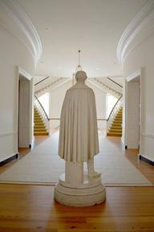Galt used a portrait of Jefferson donated by Jefferson’s granddaughter to sculpt the statue.
* When the statue was initially unveiled in the presence of Jefferson's granddaughter, Mary Randolph, she exclaimed it was the best likeness she had ever seen of her grandfather.
* Some connect the completion of this statue to the start of the Civil War, with the Confederacy looking to the iconic Jefferson as the Father of the South and proponent of states’ rights. Ironically, it was largely our claim as Jefferson’s university that saved UVA from being burned down by the Union during the Civil War.
* The statue once stood in the Dome Room. Students saved it during the fire of 1895. They first tried used ropes to lower the statue onto a library table, but the table immediately collapsed beneath the statue’s weight. Working frantically, students maneuvered the statue onto a mattress, down the west staircase and out the main door just as the Rotunda became an inferno. The statue suffered

almost no damage, save the chips in his cloak. Point the chip out to tourists; a tangible reminder helps them connect to the fire story. Also point out that the statue today serves as the mailbox for several secret societies.

**Staircases**

* These freeform staircases are modeled after ones Jefferson saw in France, although they were widened in the 1976 restoration in order to meet fire safety regulations.
* The staircases, taking four months to build, were the most complex part of the Rotunda's restoration, and the only piece not made by Virginians – they were German made.
* The material of the banisters is black walnut, a special wood that is polished by the natural oils of human hands.
* They emphasize Jefferson’s affinity for form and function: he wanted aesthetically pleasing stairs, but wanted them pushed against the wall to leave the room open for multi-purposes.

**The Fireplace in the Stairwell**

* We don’t know why this was here, or even if it was exactly in the stairwell. But during the 1970s renovation they found evidence there was a fire chute here, hypothetically to mirror the one in the North Oval Room.

**Board of Visitors’ Room (East Oval Room, Main Floor)**

This room, originally a lecture hall, is currently the meeting chamber of the

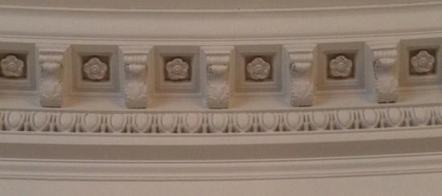University's governing body, the Board of Visitors. The Corinthian frieze, crowning

the walls, was copied from the Roman Baths

of Caracalla and is composed of acanthus leaves, rosettes, and an egg and dart motif.

**IMPORTANT NOTE:** You will not be able to enter the Board of Visitors room because most of the time it is roped off. But, the doors will be open so you can look in, and if you would like you can point out the portraits in the room.

**The Portrait of John Hartwell Cocke**

* Jefferson’s old friend, valued advisor, and a member of the BOV from the University’s inception until 1852, Cocke was intimately involved in the early days of the University and it is him who Cocke Hall is named after.
* Like Jefferson, Cocke abhorred slavery, but still held hundreds of slaves during his lifetime. He was a proponent of colonization in Liberia for freed slaves and even goes so far as the send what he viewed as his most intelligent enslaved laborers to a plantation in Alabama to prepare slaves to live independently. He eventually used some of his own money to send some of these slaves to Liberia. Some of Cocke’s slaves also worked at U.Va. in its construction.
* Cocke and John Neilson, the designer of Thomas Jefferson’s Monticello, designed his mansion (the Bremo Plantation) in Fluvanna County, Virginia which is now a National Historic Landmark. Senior Historic Preservation Planner, Brian Hogg calls Bremo, “Everything Monticello wanted to be.”
* The Small Special Collections Library holds an extensive collection of thousands of Cocke’s letters that detail his correspondence with Jefferson, fellow plantation owners, and his slaves, among others. It is in the Cocke letters that we find one of the strongest pieces of evidence backing the proposition that Thomas Jefferson fathered children with Sally Hemings. Cocke wrote (after Jefferson’s death):
  + - * “All Batchelors [[*sic*](https://en.wikipedia.org/wiki/Sic)], or a large majority at least, keep as a substitute for a wife some individual of the[ir] own Slaves. In Virginia this damnable practice prevails as much as any where, and probably more, as Mr. Jefferson's example can be pleaded for its defense.”

**A portrait of Joseph Carrington Cabell**

* Cabell was a dedicated Virginia State legislator for much of his life, despite being offered positions in two presidential administrations. Instead, he attempted to improve the educational system in the State of Virginia, a pursuit that was eventually realized in his helping Thomas Jefferson found U.Va.
* Cabell was Jefferson’s main advocate in Richmond for the University. His presence in the Legislature meant so much to Jefferson that when Cabell considered retirement in 1821, Jefferson wrote to him, “Nature will not give you a second life wherein to atone for the omissions of this. Pray then, dear and very dear sir, do not think of deserting us.”
* Cabell was involved in the earliest planning of the University in 1815 and stayed on as a member of the Board of Visitors longer than any of the other original members (until 1856 when he died).

**Thomas Sully Portrait of Thomas Jefferson**

* 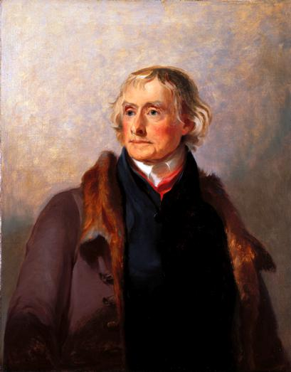Above the mantel is a portrait of Jefferson painted by Thomas Sully in 1821, oil on a panel of poplar wood with a gilt-wood frame. Jefferson posed for this portrait a month shy of his 78th birthday, while he was busily engaged in building the University, the hobby of his old age.
* West Point (the first US Military Academy, founded during Jefferson’s presidency) commissioned Sully for the portrait in 1821. Jefferson agreed, despite feeling Sully’s visit was “illy bestowed” on a man of 78, and said that whatever was left of him was at the service of the artist. Sully stayed at Monticello for twelve days in March (described as an “inmate of Monticello” for how long he stayed), but even so was unable to complete the portrait.
* Even a critic of Jefferson commented on the “dignity” and “loveliness” of the painting, depicting Jefferson as a “gentleman” in appropriate “republican simplicity”.
* This is one of the four artist’s copies. The original full-length was commissioned by West Point and still hangs in its library. Monroe owned this half-length before donating it to the Jefferson Literary and Debating Society in 1828, who in turn loaned it to the Rotunda in 1976. (Other copies can be found at the American Philosophical Society, Monticello, and the US Capitol.)

*Other important artifacts to know in this room:*

* **Brass Chandeliers:** The chandeliers on this floor are adapted from Argand lamps designed byB.H. Latrobe to hang in the United States Capitol Building (House of Representatives hall) in D.C. in the early nineteenth century. The Rotunda’s chandeliers have one tier less than the House’s three. This was an aesthetic choice, *not* one based on avoiding copyright law. Latrobe was one of Jefferson’s closest consultants in designing the University.
* **Fireplace:** In buildings of this date, fireplaces were usually built flush with the interior walls,causing the chimneys to protrude outward from the building. In the Rotunda, however, Jefferson constructed the chimneys on the inside of the building in order to preserve the cylindrical shape of the exterior.
* **Board of Visitors’ Table**: In 1976 craftsmen in Harrisonburg, VA made this 30-foot table withsolid mahogany. This table is divided into five sections, each supported (if you look underneath) by a Duncan Phyfe-style pedestal with four columns.
* **Pair of Mirrors:** These mirrors, circa 1810, help spread natural light throughout the room. Theywere a Committee purchase in 1978 and feature a gilded white pine frame, a shell motif at the base, drop pendants and garlands of acanthus leaves around the frame.
* **Oval rug:** This wool rug was woven in India in 1976 by Tibetan refugees and features an orangeand blue design, the school colors. Blue scallops surround the border, and Tibetan emblems of hope, luck, etc decorate the beige interior.
* **Green marble French Clock**: This clock is one of a French Empire Mantel Clock and is a contemporary piece from the time of the construction. These types of clocks were made in the late 18th and early 19th century in the tradition of neoclassicism that Jefferson enjoyed so much. The coolest historical fact about this clock, though, is that George Washington held its twin!

**About the Board of Visitors**

**Members:** The Board of Visitors is composed of sixteen members appointed by the Governor of theCommonwealth of Virginia, subject to confirmation by the General Assembly, for a four-year term (with a max of two terms). A full-time UVA student is selected annually to sit as a nonvoting member. (You can assume the eighteenth chair around the table is then for the President.)

**Meetings:** The Rector and Visitors meet about four or five times a year to serve as the corporate boardfor the University of Virginia, and are responsible for the long-term planning of the University. The Board approves the policies and budget of the University, and is entrusted with the preservation of the University's many traditions.

The University had no president until 1904. Jefferson was an Anti-Federalist, and thus likely wouldn’t want a strong central government for the University, which helps to explain why they meet so infrequently. (You can also connect this to his views about student self-governance or the honor system and Jefferson’s desire for the students to be largely autonomous.)

**Important first Rectors:**

* Thomas Jefferson (1819-1826)
* James Madison (1826-1834)
* Joseph C. Cabell (1834-1836 and 1845-1856)
* Thomas Jefferson Randolph (1857-1864)

**Most recent Rectors:**

* Helen Dragas (2011-2013), the first female Rector
* George Keith Martin (2013-2015), the first African American Rector
* William H. Goodwin (2015- )

**Teresa Sullivan’s “Resignation”:** Many tourists, especially visiting alumni or locals, when they hear“Board of Visitors” they immediately think about the Presidency Scandal of Summer 2012.

* A select few members of the Board, namely Rector Dragas, coerced President Sullivan to resign, citing “philosophical differences” on at least ten “very high hurdles that stand in the way of our University’s path to continued success in the coming decade”. They included faculty turnover, online education, and revenue sources like the hospital.
* The Rector did not consult one faculty member, student, or even the majority of the Board when taking this action. For ten days, many students, faculty and community members protested the decision, leading the Board to ultimately reinstate President Sullivan.
* Rector Dragas recently ended her tenure. Time will tell what this leader’s decisions will mean for the University and its reputation.

**More about Teresa Sullivan’s Resignation, and Reinstatement**

*Adapted from UVa Magazine, Fall 2012*

On June 8, 2012, the Rector of the Board of Visitors, Helen Dragas, asked for President Sullivan’s resignation. She agreed to sign the separation agreement the next day. On June 10, Sullivan’s resignation is announced and Dragas states: “The Board feels the need for a bold leader who can help develop, articulate and implement a concrete and achievable strategic plan to re-elevate the University to its highest potential. We need a leader with a great willingness to adapt the way we deliver our teaching, research and patient care to the realities of the external environment.”

On June 11, the Faculty Senate releases a statement that they were “blindsided by this decision” and they “find the Board’s statement inadequate and unsatisfactory.” Several other institutions within UVa ask the Board for clarification, but the student member of the BOV supports the decision and reminds students the Board members are “people who know and love UVa.”

On June 12, *The Richmond Times-Dispatch* obtains an email sent by Peter Kiernan, then the chair of the Darden School Foundation Board of Trustees to other board members that reveals that he had worked with Dragas and “two important alums” on the “project” of planning Sullivan’s resignation (he would resign from the Darden board two days later). In the following week students and alumni alike would begin to mobilize on behalf of Sullivan. A Facebook group and an online petition were started, and the petition got 5,206 signatures before it was closed. On June 18, the Rotunda is vandalized with the word “GREED” painted on the north side columns, and “Strategic Transparency” is painted on Beta bridge, which was a spin on “strategic dynamism,” a term that became infamous through Peter Kiernan’s email.

Under the Freedom of Information Act (FOIA), on June 19 the *Cavalier Daily* requests emails between Helen Dragas, the Vice Rector Mark Kington, and others. They later publish PDFs of all of the emails they received. The next day, about 1,000 people turn out for a faculty-run vigil on the Lawn in support of President Sullivan and the deans of nearly every school at UVa sign a letter to the Board asking for Sullivan’s reinstatement.

On June 21, as part of a “fuller explanation of the Board’s thinking,” the rector released a statement outlining 10 “very high hurdles that stand in the way of our University’s path to continued success in the coming decade.”

On June 24, an estimated 2,000-3,000 people rally on the Lawn in support of reinstatement, called the “Rally for Honor.” Finally, on June 26, the Board meets at 3 pm and votes unanimously to reinstate Sullivan.

**North Oval Room**

The north oval room serves as the room in which doctoral dissertations are defended. Yes, theses are defended at the proverbial “hot seat” in front of the fireplace, but no, it seems unlikely faculty would actually throw a student’s dissertation into the fireplace should they disapprove of it. (The fireplace no longer functions, regardless.)

It also serves as a subcommittee meeting room for the Board of Visitors.

The Ionic Frieze is a molding of the “Life and Death” cycle, symbolized by puttie (little cherub men) and oxfeld connected by branches of laurel. Though we cannot know for sure, some like to connect this motif with the “life or death” importance of a thesis to a doctoral candidate. The same motif can be found in Jefferson’s bedroom at Monticello.

**West Oval Room, Main Floor**

Originally, classes for the arts and letters were held here and most recently the room served as the President’s Reception Room to host dignitaries. This is the room where President Hereford hosted Elizabeth Taylor and then-husband U.S. Senator John Warner for a reception in 1977. At the reception, Taylor famously sat on the 18th century Duncan Phyfe sofa, which was strictly off limits, but once President Hereford joined her, the Rotunda hostess could not say anything.

This sofa is no longer in the West Oval Room and maybe for good reason. The room was repurposed in the most recent renovation to be a student study space, with the idea of the McGregor Room from Alderman Library in mind as it houses nice furniture and rugs. Be sure to be quiet when taking tourists through here so as to be courteous to students.

The frieze is Doric, with *triglyphs* and *metopes* that depict the face of Apollo, also seen in Pavilion I. This is a great example of preservationists basically guessing what these rooms looked like based off the surviving evidence of the Pavilions and their parlors.

*Other important artifacts to know in this room:*

* **Girandole Mirrors**: Purchased in 1977, these gilded pine mirrors, c. 1800-1820, have a convex shape. They’re used to enhance light in a room. They feature highly perched carved eagles set on acanthus leaf supports.

**Common Questions in the Rotunda**

**What if a tourist asks me what an artifact is or what something is made of, and I forget or don’t know the answer?**

Additional information on Rotunda artifacts can be found in the “ROTUNDA FURNISHINGS” binder found in the bookcase in the Rotunda Manager’s office. If your tourist *really* wants to know, you can direct them there. (But usually they just drop it.)

Concerning the friezes in each room, no one is sure of what was actually adorned in each room. Architects knew of several options, and made decisions on what to place where.

**“Is this original?”**

The answer to this question is almost universally no. The Medway Bell was in Jefferson’s 1826 Rotunda, as was the Galt Statue.

But nothing else in the building was in the original building. Most people will understand why this is after hearing the fire story. Most all the artifacts were either purchased or donated for the 1976 renovation, but many are 1800s “period pieces” to mimic what the furniture would have looked like inside.

The Dome Room is probably the closest in this regard to original because of the documentation in pictures (re: above the fireplaces) that we have for this room unlike the others. Even still, much of the furniture and artifacts is speculative. A cool quirk about the Dome Room, though, is that even it has not withstood the test of originality, as it is actually 16 inches narrower than the original Jeffersonian Rotunda. This is because Jefferson’s original roof was made of wood, making for a relatively light-weight design. When Stanford White and co. put on a sheet metal roof, they were afraid that the one layer of bricks supporting the roof would not be sufficient to hold up the additional weight and thus insulated the Dome Room with an additional layer of bricks.

As far as the exterior of the building goes, most of the brick exterior and interior walls on the ground floor is original and survived the fire. This can be seen in the pictures of the aftermath of the Rotunda Fire as a shell of Jefferson’s Rotunda remained.

You can also point out that the lawn rooms and pavilions outside survived the fire, and aside from some painting and roofing differences, are 90% exactly what they looked like in Jefferson’s time. Also, the friezes from parlors in pavilions are what is primarily used to speculate what the Rotunda may have looked like in Jefferson’s time and have immense influences in the modern design.

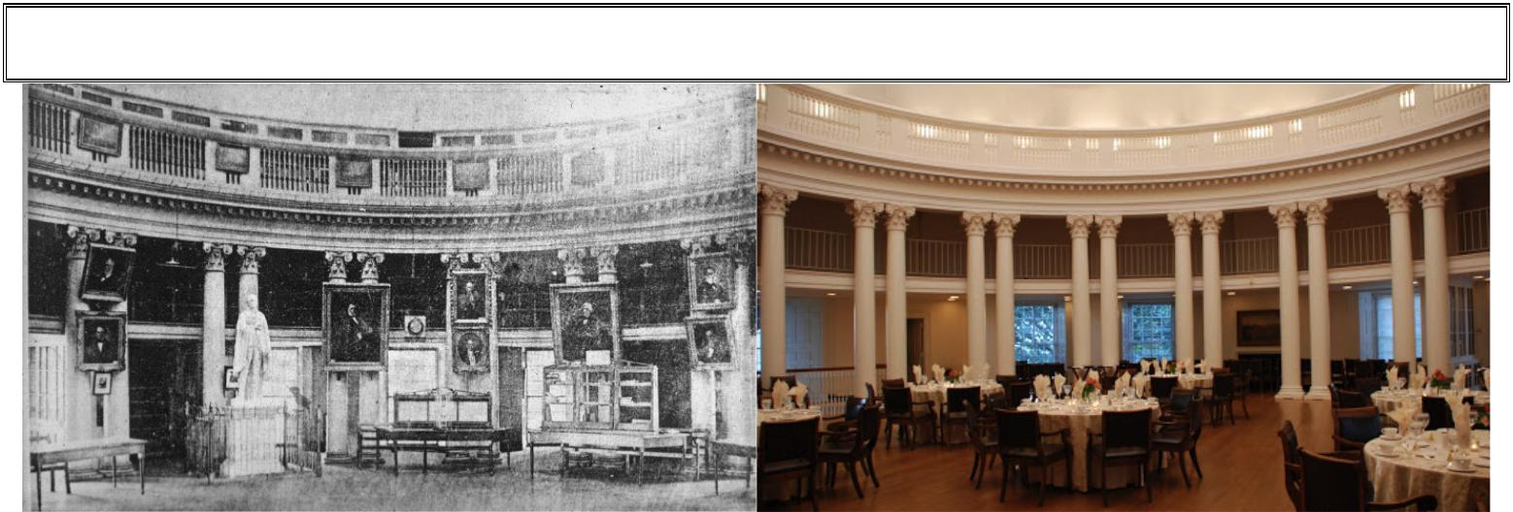**!**

**The Dome Room**

Before the Fire Present Day

**Philosophically:** The dome room is the culmination, both architecturally and philosophically, of theJeffersonian design for the original University. Strongly influenced by the Enlightenment, Jefferson's guiding principles were the forces of logic and reason. His belief in the preeminence of learning is expressed in his placement of the library in the center of the Rotunda, his temple of knowledge.

**The Dome:** The room's ceiling is a white dome, crowned with an oculus which accentuates thespaciousness of the structure. Originally, the skylight was supported on a wooden frame with spokes radiating from a central wooden axis. However, this device leaked despite various attempts to correct the problem throughout the 1800s. The skylight was replaced in 2013 to look like Jefferson’s original.

Jefferson initially envisioned the dome room with its ceiling painted blue and gilt stars imitating the night sky; he designed a movable seat from which the operator could place and move every star. Had his plan been implemented, Jefferson's idea would have given America its first planetarium.

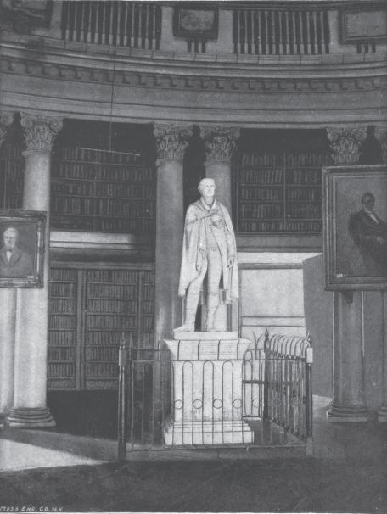

**The Columns:** The room is encircled by pairs of columnswith capitals that feature the Composite order, the highest order of classical capital. This order is a synthesis of the ornamental embellishment found throughout the building. The style is the decorative pinnacle of Jefferson's architectural masterpiece. The Dome Room is the only place on the Lawn you can find the Composite order, indicating the preeminence of the Dome Room. The crack down the middle of every other column indicates which column is load-bearing, and which simply hides the bookshelves behind it.

**The Bookshelves:** Jefferson intended that social events suchas dinners be held here. Thus, he cleverly placed the bookcases behind the room's columns so that from the center of the room the volumes of books cannot be seen. As the picture at left shows, however, the books eventually expanded to the walls as well.

**The Books:** Since 1992, Rare Book School (RBS) has been responsible for an on-going series ofexhibitions in the Dome Room of the Rotunda at the University of Virginia. The books and other materials shown in these exhibitions are drawn both from the RBS collections and from the UVa Library, supplemented by occasional loans by other institutions and individuals. The North Side of the Dome Room houses the Rare Book School’s rotating exhibits while the South Side house books from that U.Va. Library that anyone can take out and read, harkening back to the days of the Rotunda being the original library of the University.

**The Floor:** Jefferson specified that boards for the original floor were to be cut from pine trees withindesignated latitudes to ensure that the wood would be neither too burly nor too soft. In order to duplicate the original floor, antique heart pine was collected from early-19th century buildings across Virginia.

**The View:** The view of the Lawn from the dome room is one of the loveliest at the University. Jeffersondidn’t intend to enclose the south end of the Lawn, but in 1898 Stanford White built Old Cabell, Rouss, and Cocke Halls at the south end of the Lawn to compensate for the classroom space lost in the fire of 1895.

In June 1826, a few weeks before Jefferson's death and only days before he became bed-ridden, Thomas Jefferson rode down to his University for the final time. All of the original buildings of the Academical Village were finished, with the exception of course, of the Rotunda. And so, a weak and feeble Jefferson came to the top of the dome room stairs and looked out the center window over the Lawn, one of the most breathtaking views today. Below, workmen were lifting the first of the marble Corinthian capitals that Jefferson had ordered from Italy. The original librarian of the University, William Wortenbaker, brought Mr. Jefferson a chair and recounts that “he sat for twenty minutes or so, watching the lifting of the first marble capital to the top of its pillar, the one at the southwest corner. This concluded, he left the Grounds and never returned.” Keep in mind that at the time there were no buildings on South Lawn so Jefferson looked out into the wide expanse of the Blue Ridge Mountains, which many will suggest was meant to serve as an example of “the illimitable freedom of the human mind.”

You can also connect the views of the Lawn to the symbolism of Convocation (first-years welcomed, facing the Rotunda because of the knowledge they’re soon to receive) and Graduation (fourth-years facing the Blue Ridge Mountains reflecting their responsibility to now spread their knowledge to the rest of the world… which especially works if you end your tour facing the South).

**The Whispering Gallery:** The Whispering Gallery is now open to the public and provides an amazing up close view of the Composite capitals.

**Uses today:** It’s used for student study space, as well as a place to host speakers, dinners, meetings,conferences, initiations, and award ceremonies for the various organizations around Grounds.

**Pictures Above the Fireplaces:**

Over the two fireplaces in the Rotunda, there will be pictures showing the Dome Room through time. One will show the original Jeffersonian Dome Room before the fire, and the other will show the Stanford White Dome Room. Because of the pre-Fire picture, the University has been able to restore the Dome Room to a very similar version of its original likeness. The Stanford White Dome Room, on the other hand, offers a very interesting glimpse into the far more open and aesthetically dramatic design of the room from 1896-1976.

**PART 4: THE LAWN**

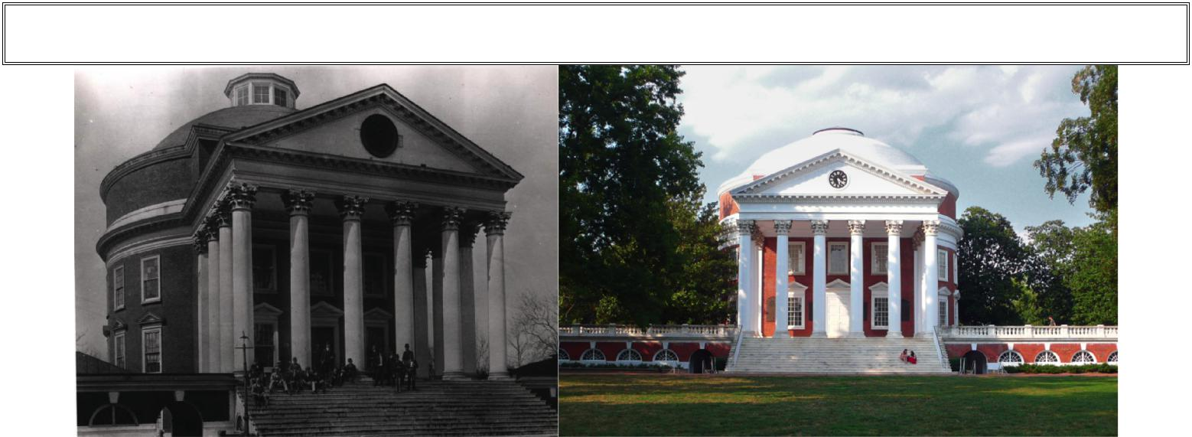

**Exterior of the Rotunda**

!

1892* 2008†

The exterior of the Rotunda is of Corinthian Order. Remember, only the Dome Room contains capitals of the Composite Order. Replacing the exterior Corinthian capitals was one of the primary motivations for the most recent restoration of the Rotunda. The prior capitals were extremely susceptible to breaking apart (obviously a huge liability for the University if a chunk fell on an unsuspecting visitor) due to chemicals that had been sprayed on the capitals to prevent birds from perching on them.

**The Willard Clock** *(big black clock, seen left)*

Jefferson was obsessed with time, so naturally the University’s clock had a prominent placement in the Academical Village so students could regulate their own days. Jefferson charged his granddaughter’s husband with finding him a clock in Boston, and he found Simon Willard, the “best clock-maker in this place”. (His clocks can be still be found on the nation’s Capitol and Supreme Court building.)

The fee was $800, the order was placed, but the project got delayed—the Rotunda’s capitals and bases had just arrived from Italy and an expensive import duty tied up the University’s funds. Jefferson had to claim the items as *educational tools* for his University rather than luxury goods for Congress to waive the duty. A triumphant Jefferson wrote to Coolidge a few weeks before he died, “I am now authorized to close with Mr. Willard for the undertaking of the clock…”

Some argue the pockmarks on the Medway bell aren’t just from being rung, but from bullets when students missed their intended target: the clock. The clock, which one student nostalgically lamented “never kept time,” had its hands repeatedly shot off by students. One student in particular (and future Chairman of the Faculty), Paul B. Barringer, describes its abuse…

*Securing a little ammunition, we took potshots from and upper room in House E [Dawson’s Row], thus breaking the usual academic calm. Our favorite target was the clock face on the Rotunda, which was well peppered before the guns were recalled. By standing far back in the room, no telltale smoke came forth, and we risked only one or two shots a day, but soon [Professor James F. Harrison, Chairman of the faculty] was tearing his hair. Twenty-odd years later when the University was presented with a new clock, I, as chairman, ordered a bullet-proof face, a unique order at the time.*

Thus, drawing on his own transgressions as a student, he created probably one of the first bulletproof clocks in America in the early 20th century.

* The cupola seen on top of this Rotunda was added at some point during the 1880s to improve the waterproof quality of the dome roof, creating a watertight roof without sacrificing light in the Dome Room.

† Note: the current Rotunda features a plaster eagle, seen under the southern portico ceiling, copied after the ornament on Monticello’s hall ceiling.

The Willard Clock was destroyed in the Rotunda Fire. Then, Stanford White got a slightly smaller clock to replace the old one, called the Howard Clock, as well as a companion for the North side of the Rotunda. And then, in the most recent renovation, the clocks were replaced again, much in the design of the original clock.

**Courtyards and North Terrace –** When Jefferson designed the Rotunda in 1819, the east and west courtyards and north terrace did not figure much into his design. His main entrance was situated on the Lawn Side and thus he did not give much thought to the aesthetics of the Rotunda from the North. He does not put a clock on the North façade of the Rotunda either. In Jefferson’s day, the courtyards had wooden roofs and served as outdoor exercise spaces, even in inclement weather. McKim, Mead, and White included landscape plans for these spaces but it was not until the most recent round of renovations that significant funds were dedicated towards renovating these spaces. Today, the east courtyard houses a fountain and benches while the west courtyard is a paved space where tables and chairs can be set up for events. The North Terrace houses the two flags and the Jefferson Statue which appears to guard his University as it looks out towards University Avenue.

**A Cow on the Rotunda**

Call it the great university cow caper. After years of speculation, the University of Virginia knows the culprits behind a prank that has long been the subject of mystery and local lore.

In the summer of 1965, a cow mysteriously ended up on top of the campus Rotunda. More than 30 years later, UVa graduate and current NASDAQ president, Alfred Berkeley III, has admitted that he and his friends orchestrated the stunt. Back in May of 1965, however, Berkeley and several of his Delta Kappa Epsilon fraternity brothers became involved in the decidedly un-presidential prank.

“We had a cow that was given to us by the father of one of the fellows who was in this group and we put it on the roof of the Rotunda, and then when it got to be sunlight, we went to classes and came back and there was a growing crowd of people on the Lawn,” he said. After about two hours and a great deal of coaxing, Berkeley and his fraternity brothers carried the cow up a winding set of stairs to the roof of the Rotunda. But what comes up does not necessary have to come down, as the students found out. The bovine died from an accidental overdose of Valium given to it by veterinarians.

The caper remained a mystery for 30 years, until Berkeley confessed his role in the mystery at an alumni dinner. An alumni magazine picked up the confession, and it caught the eye of George Bailey. As the sheriff of Albermarle County in May of 1965, Bailey had expended a great deal of time and effort trying to find the culprits behind the prank. He even searched local farms for missing cattle, to no avail. Bailey wrote to the NASDAQ president and spoke to him on the phone. Berkeley agreed to donate money to a local animal rescue squad equal to the sheriff's expenses.

“I estimated about how much money I was making at the time. I think it averaged out about $30 a day ... and it came to $1,765. And so when I wrote the letter Mr. Berkeley called me up and laughingly said that looked right high but he was going to send me a check,” Bailey says.

**The Pavilions of the Lawn**

Adapted from Richard Guy Wilson’s *The Campus Guide: The University of Virginia*

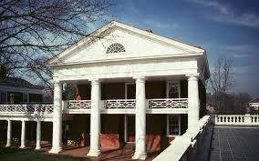

**PAVILION I**

**Order:** Doric, basedon the Baths of Diocletian seen in Chambray

**First Resident:** John P. Emmett, Natural History and Chemistry

**Current Resident:** Robert Pianta, Dean of the Curry School of Education

*Important Facts:*

* **The Frieze:** The face is that of **Apollo Kouros**, or Apollo the Youth. Greek sculptures commonlydepict kouri (young men, not quite yet adults… like the original boys of the University), particularly Apollo (an “eternal beardless youth”), with long hair as a marker of their young age. Upon attaining manhood, their hair would be worn short for the rest of their lives (like the students leaving as citizens, ready to take their place in the world). This Frieze is also seen in the President’s Reception Room.
* **The Staircase:** This illustrates Jefferson’s belief in form and function. Like in the Rotunda, byplacing the staircase to the side (in this case, directly in the window), you waste less space and allow more natural light to spread than had it been in the middle of the room.
* **The “Zoo”:** One subject Prof. Emmett taught was zoology, and he had quite the collection ofanimals in his garden: birds, snakes, silkworms, a wooded owl, horse, and even a young brown bear.
* **The Balcony, Part I:** Roman temples were only one story tall, but Jefferson, of course, needed twostories to realize his dream of classrooms and residences in the same building. So, he designed the long window and floating balcony to create the illusion that the Pavilion is only one story.
* **The Balcony, Part II:** The floating balcony is supported by iron rods (the first use of exteriorstructural iron in America). The rods replaced after the balcony collapsed during the 1997 Commencement, during which a woman sitting nearby died from a heart attack (*not* from being struck by the balcony). A plaque was placed there in her honor.
* **The Doors** *(to the pavilions and on the Rotunda main floor)***:** They’re made of Virginia pine (asJefferson wanted the entire University constructed from Virginia materials, and pine is certainly plentiful here), but they’re to this day still stained to look like mahogany through a (then popular but now quite expensive) process called “graining” (even though today it’d just be cheaper to replace the doors with mahogany).

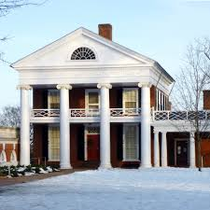**PAVILION II**

**Order:** Ionic, based on Palladio’s Temple of Fortuna Virilis

**First Resident:** Thomas Johnson, Anatomy

* **The Frieze:** The frieze contains carvings of bucranium (ox skulls) and cherubs, like in the NorthOval Room, a very common design in ancient Roman architecture.
* **The Inspiration:** The temple of Fortuna Virilis in Rome is known as “The Temple of MasculineVirtue.”

**PAVILION III**

**Order:** Corinthian, based on Order of Palladio

**First Resident:** John T. Lomax, Law

**Current Resident:** Harry Harding, Dean of the Batten School of Leadershipand Public Policy

*Important Facts:*

* **The Capitals:** Although Pavilion III is the smallest on the Lawn, it was the most expensive to buildbecause of the extremely ornate Corinthian capitals, carved from Italian marble, atop the pillars.

**The Raggi Brothers:** In 1819, Jefferson contracted Michele and Giacomo Raggi from Carrera, Italyto come to Charlottesville to fashion, out of native Virginia stone, Corinthian and Ionic capitals for the pavilions and the Rotunda. Though they spoke no English, Jefferson seemed confident in their abilities, until four days after arriving when the Italians examined the quarry and “pronounced it impossible to make of [the stone] an Ionic or Corinthian capital”, claiming the native Virginia sandstone was too hard a material to produce the intricate capital designs. The brothers did attempt to carve it, but complained bitterly. By September they asked to be sent back to Italy to carve the capitals in less time and for half the expense (and also because they missed their wives). Jefferson did not relent, so their demands continued: for money and for housing and for a paid visit for their wives. Eventually Michele sunk into “great despondency” and was unable to work because of a sprained wrist. Jefferson lamented, “In this state of body, and homesick, & lovesick mind, he will be of no use to us.” and was prepared to release the needy, badgering brothers of their contract. Michele returned to Italy, leaving Jefferson having wasted $1390.56 on the brothers who never produced the desired capitals.‡ As an interesting epilogue, Giacomo had actually stayed in Charlottesville until he learned of his wife’s death in October 1821. He returned to Italy in 1822, but by year’s end was back in New York, intending to return to Charlottesville at the Board’s request to carve the bases for the Rotunda’s capitals. The Board ended up sending him to Italy, where he never finished his work, and the University opened in 1825 with an unfinished Rotunda.

* **The Import Tax:** Jefferson’s associate in Italy found other stonecutters to take the order, and theCarrera marbles eventually arrived from Italy in Boston’s port. When the capitals arrived in Boston, they were met with an exorbitant import duty imposed by Congress on luxury goods. Jefferson successfully avoided the duty by writing to Congress and emphasizing the educational nature for which the capitals were destined (for his 3-D architectural textbook). Note: these were capitals not just for Pavilion III, but also for the Rotunda and a few other pavilions.
* **Two Doors:** At Pavs 3 & 7, the earliest built, one door was used for classroom space; the other forfamilies to return home without disrupting lectures. It’s not known why others only have one door.
* **The Harmon Family:** Beverly Harmon, Assistant Dean of Students at the Law School, and herhusband William Harmon, Sr. Vice President for Development, lived here from 2000-2005. They were the first African American pavilion residents, and were known as being well-liked and extremely close to the community.

**PAVILION IV**

**Order:** Doric, based on Temple of Albano (as illustrated by Chambray)

**First Resident:** George Blaetterman, Modern Languages

**Current Resident:** Larry Sabato, Director of U.Va.’s Center for Politics

*Important Fact:* **The Balcony Railing**is a Chippendale railing, differentlydesigned than other pavilions to perpetuate Jefferson’s theme of using the Lawn as an architectural textbook.

**PAVILION V**

**Order:** Ionic, based on Palladio’s Villa Malcontenda

**First Resident:** George Long, Ancient Languages

**Current Resident:** Patricia Lampkin, Vice President and Chief Student Affairs Officer

*Important Fact:* **The six imposing columns**give this pavilion a commandingpresence. The capitals are made from the same Carrera marble as Pavilion III and the Rotunda.

**PAVILION VI**

**Order:** Ionic, based on Theater of Marcellus (as illustrated by Chambray)

**First Resident:** Charles Bonneycastle, Natural Philosophy

**Current Resident:** Bob Sweeney, Senior Vice President for Development and Public Affairs

*Important Fact:* **This pavilion is one of the simplest.**It lacks a large order. Ithas smaller windows. The colonnade is outset enough to create the porch.

**PAVILION VII**

**Order:** Tuscan and Doric, based on the Temple of Albano (as illustrated byChambray)

**First Resident:** Library and Administrative Offices

**Current Resident:** Colonnade Club

*Important Facts:*

* **The first pavilion:** It was the first pavilion built, with the University’s (then Central College)cornerstone laid on October 6, 1817 in the presence of Thomas Jefferson, James Madison, and then President James Monroe (on whose land the University was built, and a statue of whom used to be where Homer is now).
* **The arcades:** It’s the only pavilion to feature an arcade, and it is ironic that Jefferson chose to usearcades at all because they were expensive and blocked out natural light. He did end up using arcades in front of all the Range rooms, however.
* **The original library:** Pav 7 served as temporary library before the Rotunda was completed.
* **The Colonnade Club:** Founded in 1907, Pav 7 has been this faculty and alumni social center,named somewhat ironically since this is the pavilion on the Lawn not featuring a colonnade.

**PAVILION VIII**

**Order:** Corinthian, based on Baths of Diocletian

**First Resident:** Professor and Mrs. Thomas Hewett Key, Mathematics

**Current Resident:** John Colley, Professor of Business Administration, DardenSchool of Business

*Important Facts:*

* **Uniqueness:** It’s the only pavilion that retains the original purpose as a classroom and faculty livingspace after restoration in 1984-85 (after many years as the Presidents Office). It’s also only one of two pavilions with Corinthian columns, and the only pavilion with arched windows (found on the ground floor).
* **History:** Prof. Echols occupied this pavilion during the 1895 Rotunda fire. In the late 1940s, Pav 8 served as the office of the president before moving to Madison Hall in 1984.

**PAVILION IX**

**Order:** Ionic, likely based on the Hotel de Guimard and other Ledooux structuresin Paris; Ionic facade, based on the Temple of Fortuna Virilis

**First Resident:** George Tucker, Moral Philosophy

**Current Resident:** Dorrie Fontaine, Dean of the School of Nursing

* **The columns** are found within the recessed niche. Pavilion IX lacks a giant order.
* **French inspiration:** It’s only pavilion not modeled after a Classical temple. Jefferson likely saw the

hotel that’s believed to have inspired this pavilion while in France from 1784-1789.

**PAVILION X**

**Order:** Doric, based on based on the Theater of Marcelus from Chambray

**First Resident:** Robley Dunglison, Medicine (first full-time medical professor at an American University

*Important Facts:*

* **The base:** Unlike the Roman Doric, Jefferson specified no base here, gesturing towards the Greek.
* **2010 Renovation:** In 2010, Pav 10’s parapet (once removed in 1870) was restored, and the whitepaint was removed from the limestone columns to restore the pavilion to the Lawn’s original sandy colors.§ (Indeed, the iconic “Red Brick / White Paint” is only half true: the white paint was likely added in the late 1800s to cover the columns’ many pockmarks and sun spots.)
* **Dissections:** Because Prof. Dunglison felt his front room was not the appropriate place fordissections, Jefferson built the Anatomical Theater (now gone) across McCormick Road.
* **Honor:** The assassination of Prof. Davis, which many argue led to the formation of the HonorSystem, occurred at this pavilion.

Will this this color change occur on the rest of the Lawn? Time will tell. Some call Pavilion X a “litmus test” to assess public reaction to the change. While there are no current plans to implement this change across the rest of the Lawn, University Architect David Neuman has said he’d like to see us “move forward with restoring the entire Lawn to the Jeffersonian design”. The same debate between historical accuracy and aesthetics occurred before the 1970s Rotunda renovation, and historical accuracy won. It will be interesting to see how this debate plays out on the Lawn outside.

**Other Aspects of the Academical Village**

**Hierarchy through Architecture:** Jefferson infused many examples of establishing importance througha building’s specific design. Jefferson used better bricks for professor housing than for students’. Walk a tourist up to where the bricks of the pavilions meet the bricks of the lawn rooms, and you’ll notice how the nicer pavilion bricks have better withstood the test of time. (Even the upper floors of the pavilions, where the professors lived, had nicer cornices than the lower floors, where students learned.) But most notably, the different styles of columns employed in the Village establishes a hierarchy: student rooms were lined with Tuscan bricks, there are 4 Doric pavilions, 3 Ionic pavilions, and 2 Corinthian pavilions, and the only composite style is in the Dome Rome, the original library.

**Asymmetries:** Each pavilion is different from the others. There are more lawn rooms between thepavilions as you head south on the Lawn. There are 28 rooms on the West Lawn compared to the 26 on the East. The Lawn contains 54 student rooms, while the Range contains 55.

**Room 21, West Lawn:** From the bricks, it’s clear this room was a later addition to the AcademicalVillage. The space was likely left open to provide easier access to the Lawn for construction materials, carts, and workers, but the room was probably added at some later date when the wide passage was no longer needed.

**The Grass:** Jefferson’s only plan for the Lawn itself was “grass, trees, etc.” It does provide breathtakingviews, though. Remind tourists of how you felt when you first saw it, and what it means to you now.

**The Ranges:** These student rooms are identical to those on the Lawn (save for Room 13’s memorial toEdgar Allen Poe), and are now occupied by select graduate students.

**The Hotels:** These were the original dining halls of the University (though Hotel F served as theUniversity gymnasium at one point). Most of the hotelkeepers Jefferson hired only took the job in hopes of having their own sons admitted to the University, and many complained the boarding fees were too low. ** The hotelkeepers were meant to be upstanding members of the community, to prevent students from drinking and gambling within their eateries… but it turns out many of the proprietors themselves were notorious for initiating this behavior. NOTE: the Hotels were never foreign language immersion houses. Jefferson did like the idea, but he never planned that the Hotels would serve that function.

**The Gardens:** Jefferson left no specific record of his intentions for the pavilion gardens.As illustratedat Monticello, Jefferson's ideal garden combined pleasure, utility, and a place for thought and study. Jefferson intended the Pavilion residents to design, plant, and maintain their own gardens. Some were cultivated with great care, others were used for predominately utilitarian purposes and included smokehouses and sheds for small animals. The Garden Club of Virginia restored the West Gardens from 1948-1952 and the East Gardens from 1960-1965, choosing plants known to Jefferson and reconstructing garden sheds that were once “necessary houses” or “privies”. The club continues to guide the care and maintenance of the gardens today. The gardens are open for the public to enjoy. For any visitor interested in the specifics of each garden, simply tell them to Google: “Explore UVA Gardens”.

** “Boarding fees” comes from the term “Room & Board”—it seems that, at the time, the fee students paid for a “meal plan” went straight to the hotelkeepers.

**The Serpentine Walls:** The Garden Club also renovated these walls, which are very economical:they’re one-brick thick but still stabilize the wall as well as a straight wall would have.

**The South Lawn:** This project was completed in 2010 and provided new academic buildings for thegrowing College. Still it pays respect to Jefferson’s architecture in the nearby Academical Village: a 100-foot wide terrace seems to extend the Lawn just north of it.

**The Inscription on Old Cabell:** The Greek inscription on the pediment entablature translates to “Yeshall know the truth, and the truth shall make you free.”

**The Basement Grates:** The windows of the Pavilion basements were not installed until 1900 at least.Slaves were not kept behind these grates, as those grates did not exist. The spaces were probably used for storage instead of slave quarters. Instead, slaves probably lived in the numerous outbuildings around the Academical Village and under student rooms, especially on the East Lawn.

**The Painted White Mortar Lines:** The masons did a poor job of constructing the exterior pavilionwalls for aesthetic pleasure (there were splashes of mortar everywhere) so some pavilions walls (like on Pav 2) were painted with a red paint, then white-wash was used to paint over the lines between the bricks.

**UNESCO:** In 1987, UNESCO (the United Nations Education, Scientific, and Cultural Organization)named the grounds of the University of Virginia (along with Monticello) a World Heritage Site, for Thomas Jefferson’s contributions to American architecture and the ideas they emblemize. The list of places on this prestigious list includes the Taj Mahal, Versailles, the Statue of Liberty, and the Great Wall of China. We are the only university in the nation on this list, and one of only eight man-made sites in the U.S. listed. It’s also incredible to be on this list as an institution that’s still used for its *original* *purpose:* lived in, learned in, and open for business.

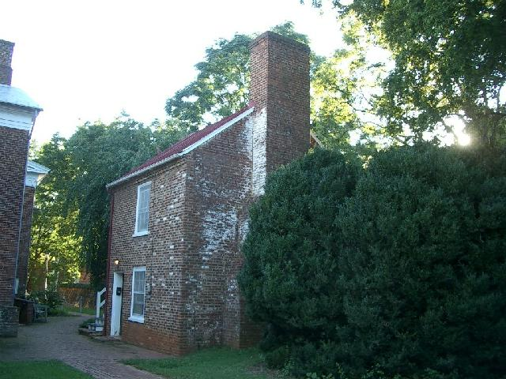

**The Cracker Box:** The most likely vestige for slave-quarters on the Lawn is the Crackerbox, a queer two-story cottage to the rear of Hotel F, at the foot of Garden X. Its full history is uncertain. Its date of establishment is unclear (cropping up in a couple of mid-1800s engravings, but even

today omitted from many depictions of the Village… either due to insignificance or to cover up its possible history as slave-quarters or a brothel). It’s likely not an original building, but *was* around as early as 1840. It eventually became a kitchen of some sort, and a woodshed by the early 1900s. It’s been a student accommodation since – intermittently during the 1930s, and continuously since the 1960s following renovation and remodeling. Currently it houses notable range residents and the range council president.

**Other Buildings**

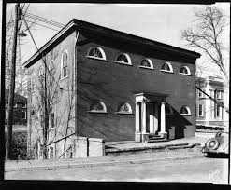**The Anatomical Theater:** This building was the University’sfirst (and Jefferson’s only) attempt to expand beyond the Academical Village. This was the last original Jefferson building constructed (built in 1825 to accommodate dissections), but was razed in 1938 to make way for Alderman Library. (There are monuments where the four corners of the building once stood, however.) The most remarkable aspect of this building was its spare, utilitarian quality. Unlike the rest of the Village, it was built with function foremost in mind, its form a relative afterthought. The most modern of all Jefferson's realized designs for the university, it is also the only one that has been demolished.

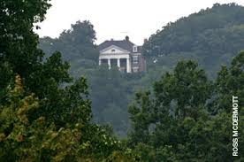**Kearney Mansion:** No, this house on Lewis Mountain, easily seenfrom Alderman Library, is neither Monticello nor Dr. Seuss’ house (looking over Hoo-ville). It was built in 1909 and stands at an astounding elevation of 882 feet. The mansion was first occupied by (and named after) retired General John Watts Kearney. The home has switched hands a number of times since his death, but it is rumored that the current occupants are very unreceptive to visitors.

**Pavilion Residences**

**Are the pavilions still the same as they were in Jefferson’s time?**

Nearly all the pavilions have been enlarged, and nearly all has a unique history of changes, like wall additions or stair removals or doors and windows changing places. That said, the exteriors are still very much what Jefferson knew.**!**

**Have they always been used for housing?**

Classes were held in the pavilions, as Jefferson intended, until around the time of the Annex construction. The ideals of the Victorian household conflicted with strangers entering the home. The pavilions became entirely used for faculty housing.

But the University eventually became short on space and began co-opting the pavilions for institutional purposes. In 1904, the professor in Pavilion IV was evicted to make room for an office for the new President Alderman, and later Pavilion VIII served the same purpose. Pav III was refashioned as the Graduate House from 1924-1953, and Pav VI was once vacated for the Romance languages department. In 2014, Pav II and III will house offices for the College and VPSA, respectively.**!**

The pavilions’ original purpose has ascended again today, however, with faculty back to living in all the pavilions but the Colonnade Club in Pavilion VII.

**Who selects who lives in the Pavilions?**

The selection process was originally done by drawing lots, but recently has followed an order of precedence set by the Board of Visitors: priority is given to the Provost and any vice president nominated by the president and agreed to by the board. Thereafter, preference is given to academic deans in order of the founding of their 11 schools, followed by full professors.

The apartments in Pavilion VIII are the exception: junior faculty are encouraged to apply, and a three-person committee (of the secretary of the BOV, the chair of the Faculty Senate, and the student recipient of the Gray-Carrington Award) nominate a candidate to the board.

**How long can faculty members live there?**

Professor tenancies used to be extremely long, upwards of 20 to 40 years. Chair of natural philosophy Francis H. Smith holds the record, living in Pavilion V for 69 years from 1859-1928. Today, leases are five years, with a maximum stay of 10 years.

**Do they pay to live there?**

Yes, pavilion residents pay a monthly fee (somewhere between the $600 a month for Pavilion VIII’s lower apartment to Pavilion V’s $1800 a month rent). This includes utilities, but cable TV is extra.

**Do they have modern amenities?**

Though built with no indoor plumbing, central heating, gas or electricity, today they are laden with utilities and services necessary for the comfort and technological demands of modern living.

**Can they decorate it as they wish, or are Pavilions too historic to change?**

Residents are free to decorate and furnish the pavilion to their liking; a period look is not mandatory. That said, they can borrow furniture from UVA’s warehouse of new and antique pieces, and art can be borrowed from the art museum. They also must follow a few rules: they can’t change the paint color downstairs, they can’t use the fireplaces, they can’t hang pictures of themselves on the walls, and they can’t dig in the gardens.

**Lawn Room Residences**

**Have the Lawn Rooms always been student rooms?**

From the earliest days of the University, professors who needed more room could petition the Board of Visitors for permission to take over a room on either side of their Pavilion, and this was fairly common. (When entering the Colonnade Club, the door on your right once led into Room 33 at the time of the Civil War.) Even into the 1950s, a Dean in Pavilion II held his office and that of his secretary in the rooms adjacent to his pavilion, but their offices were likely the last such use of student rooms.

Some Range Rooms today are used for more than just dormitories. The women’s bathroom on the West Range occupies two rooms, and of course #13 is Poe’s room.

**Have the Lawn Rooms always been an honor for students to live in?**

For the first 100 years of the University, the Lawn was simply one of the few places students *could* live (though almost always with a roommate).

Students likely became less interested in living on the Lawn around the 1910s after a proliferation of fraternity houses and board houses were built behind the Corner. Into the 1950s, it was still considered “a Good Thing” to live on the Lawn, but it was not a really big deal, especially since the much nicer McCormick Road Dorms had just been built.

The application into the 1950s was very short, and no one outside the Housing Office would have seen it. Housing didn’t object whenever a couple of friends wanted to trade off so that each got to spend a semester on the Lawn. Several students stayed on the Lawn for more than one year, but it was becoming less and less common.

The competitiveness in its modern sense (with a student vetting committee, etc.) escalated over the next couple decades, and it has since become “a Very Big Deal” to live on the Lawn. Today select students in their last year of undergraduate study live in each room, and can only live there for one year.

**How do they select who lives in the Lawn Rooms today?**

The Organizing Committee, led by the Dean of Students, determines the composition of the Lawn Selection Committee. Currently, the Selection Committee is composed of 48 Fourth-Year students. 24 are ex-officio members representing a diversity of experiences and perspectives at UVa.†† The remaining 24 committee members are selected by a random process. The Organizing Committee also determines the criteria for selection (i.e. writes the application). The applicants are held to high standards of scholastic and extracurricular achievement, and look for evidence of continued commitment on the Lawn as well.

The process is blind, so the students reading do not know the names associated with the applications they are reading. Each member individually selects the applicants he/she feels would compose a qualified, well-rounded community; the committee does not collectively discuss applicants. Member votes are tabulated and applicants are ranked based on the number of votes each applicant receives from the committee. Applicants are then informed of the decision (accepted, waitlisted, denied) via email.

There are endowed rooms, however, that each have their own process. (As does the Range.)

††These ex-officio members include the StudCo president, Honor Chair, UJC Chair, SR of the Lawn, Fourth Year Trustees President, and representatives from the ASU, BSA, IFC, ISC, MGC, NPHC, QSU, Student Athlete Advisory Council, and transfer students.!

**Do you pay to live on the Lawn?**

Yes, rent is $5930 for the 2013-2014 school year. (Though 50 East is $150 cheaper because it has no fireplace.) Cable TV is extra. Endowed rooms may cover part or all of the year’s rent.

**Do they have modern amenities?**

There’s electricity, a radiator and a fireplace for heat, a ceiling fan, and a sink in each room, but there is no A/C, bathrooms, or kitchens. You have to purchase wood for the fireplace from a vendor.

The main bathrooms are in freestanding structures in the alleys behind the Lawn. You have to purchase the Lawn Robes.

There is one laundry room for the entire Academical Village close to Pav 8, or you could pay for a laundry service to pick up and drop off your clothes.

Mail is delivered through the slot on their door, and packages left on their doorstep.

Residents can park their cars in the Emmett/Ivy Garage.

**Can they decorate it as they wish, or are Lawn Rooms too historic to change?**

The room comes furnished with a desk, a chair, a bed, the rocking chair, the built-in closet, fireplace tools, and a small mounted wall shelf. Lawnies can otherwise make or bring their own furniture.

Lofts and other cabinets cost extra, and are arranged by the individual Lawnies. (Gary Lettan is the unofficial Lawn carpenter—he makes and stores may of the pieces that get passed down year to year.)

You’re free to cover 10% of the walls with decorations.

**Can you drink alcohol in the Lawn Rooms?**

If you’re 21 you can drink in your room, store alcohol there, and invite other 21-year-olds to drink, but you cannot have open containers on the Lawn. Minors can still be arrested for drinking in your room, and sometimes the Lawnie themselves can be charged for providing alcohol to a minor. For fire code, they’ll issue bracelets for tailgates to control crowds in rooms, but this rule is not strongly enforced.